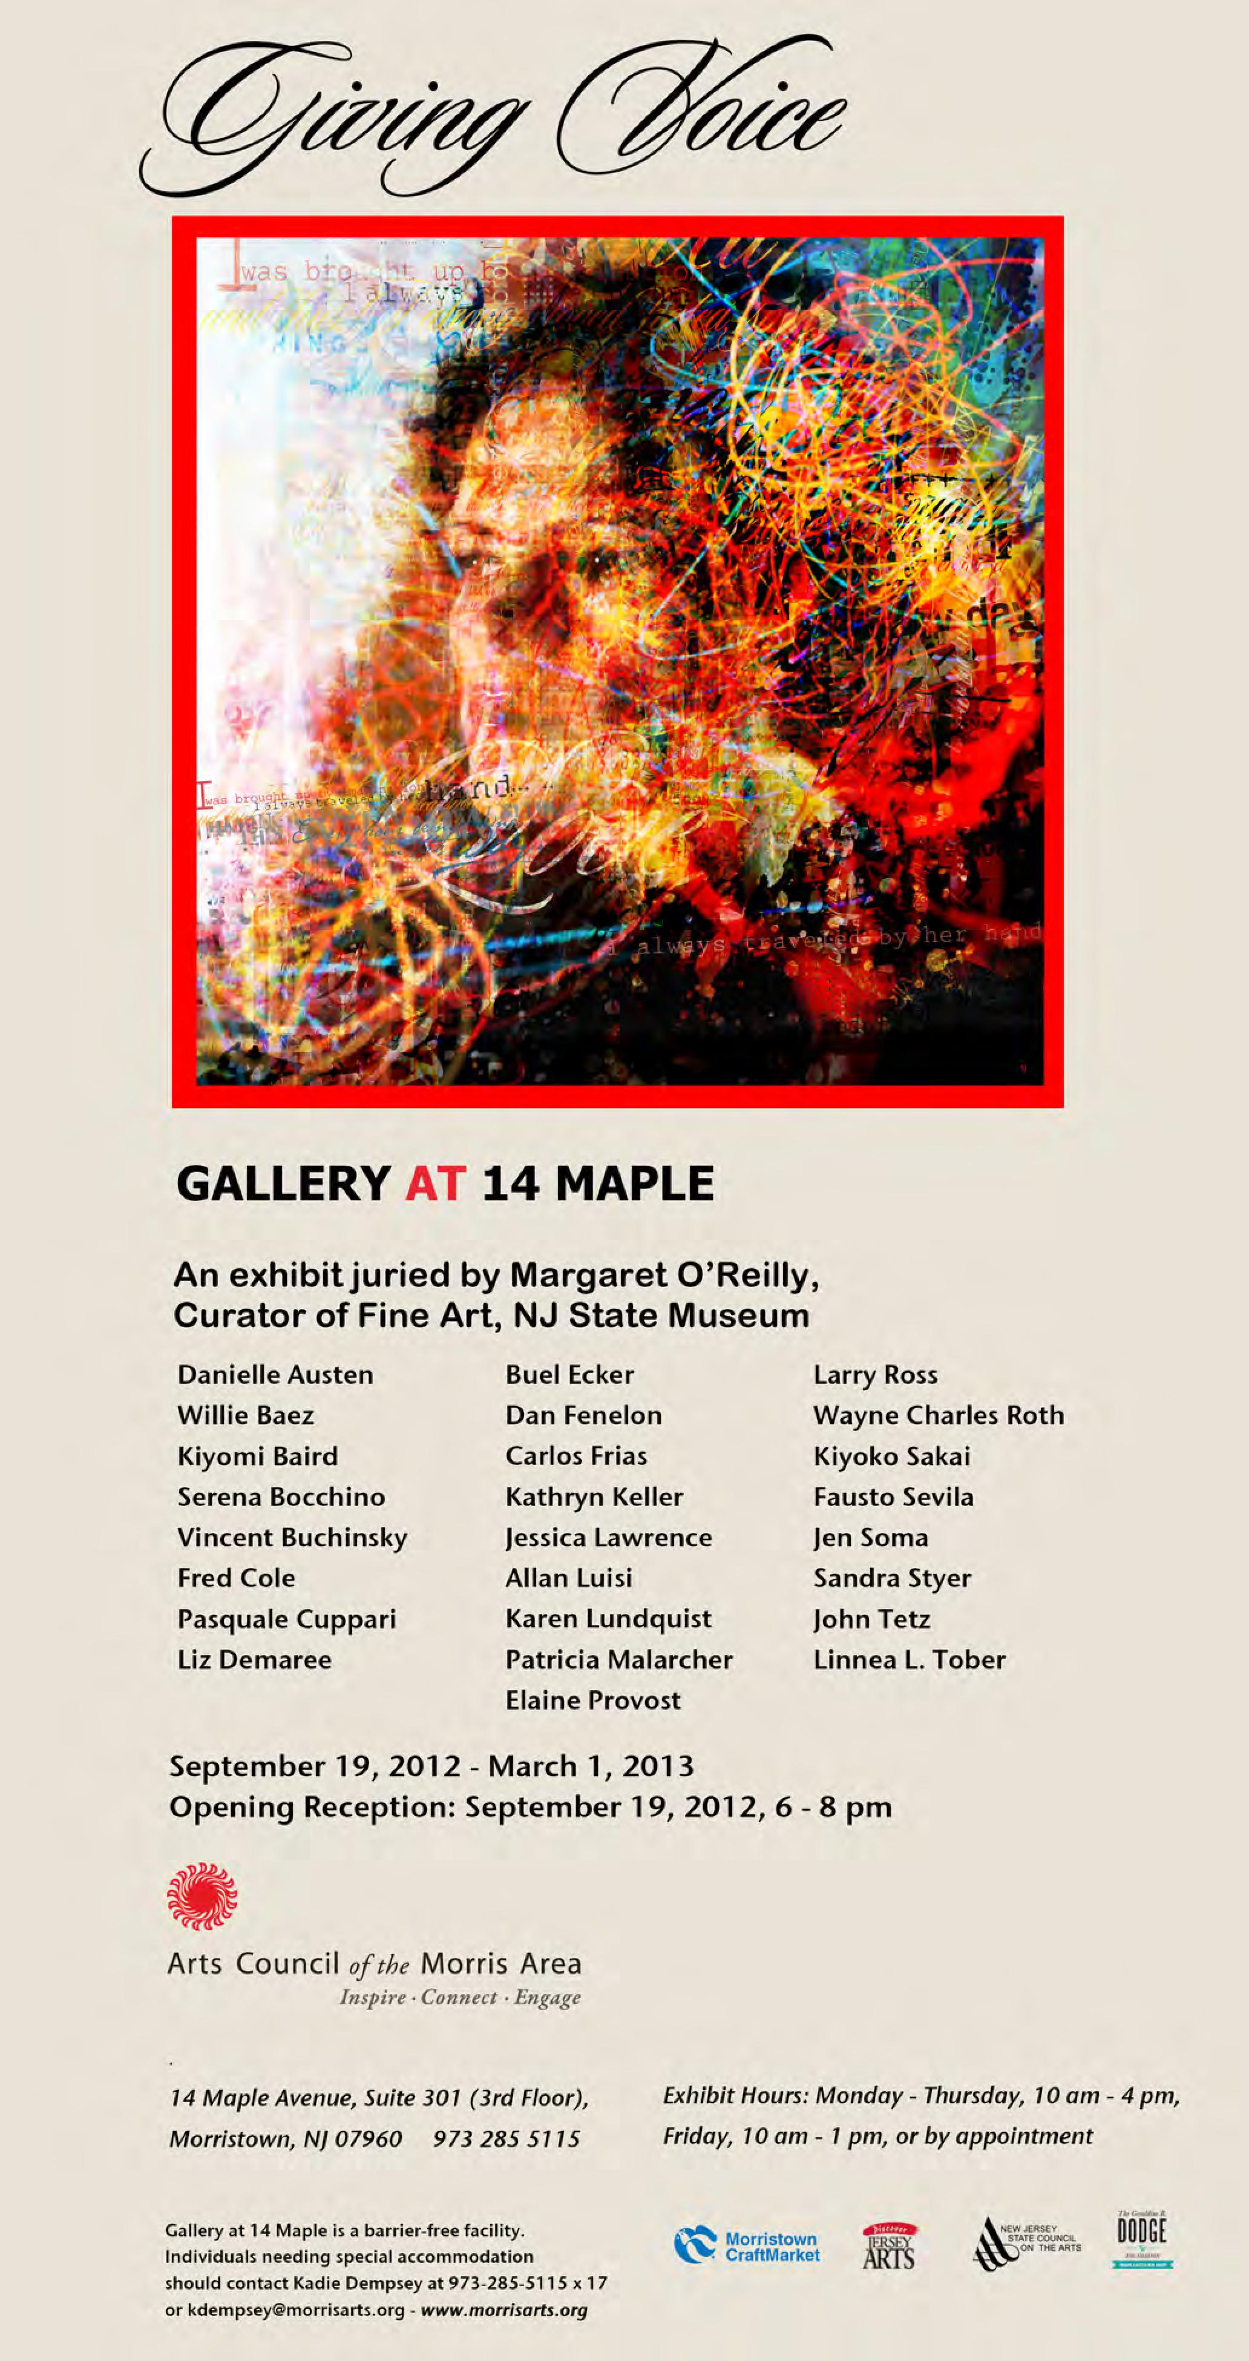
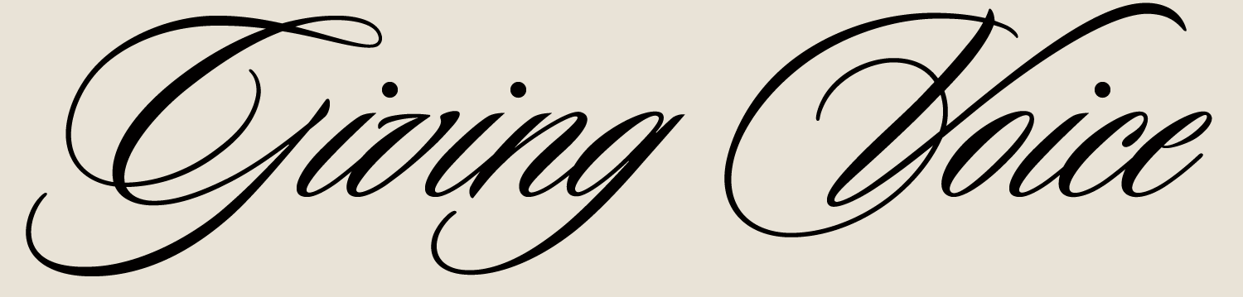

This exhibition celebrates, and is in conjunction with, the 14th biennial Dodge Poetry Festival, North America’s largest poetry event, which takes place on October 11-14, 2012 in Newark, New Jersey. An overarching theme of the Festival, the process of “giving voice” allows the individual to bring his or her individual experience (their “voice”) to the words of a poem. In keeping with that theme, artists were invited to submit a visual interpretation/response to this excerpt from the poem entitled “Time’s Passage” by Fernando Pessoa (also quoted on the 2012 Dodge Poetry Festival poster):

I was brought up by Imagination,
I always travelled by her hand,
And thus I always loved, hated, spoke, thought,
Having every day this window before me,
Every hour being mine in this way.

The artists who submitted work to the jury process each approached the theme by sharing with us their unique voices and their creative visions. The challenge was to avoid literal depictions or interpretations of the excerpt. Imagination clearly informs the layered meaning and imagery of the selected works, yet each visually considers the singular moment or the illusiveness of time.

Several artists – Danielle Austen, Dan Fenelon, Jessica Lawrence, Allan Luisi, Wayne Roth and John Tetz – work graphically, boldly expressing their vision in clear, purposeful visual language. Abstraction is the vehicle for Kiyomi Baird, Serena Bocchino, Pasquale Cuppari, Buel Ecker, Carlos Frias, Kiyoko Sakai, Jen Soma, Sandra Styer and Linnea Tober to explore their world and share with the viewer their singular visions of time, place and space, as well as color, form and composition. Vincent Buchinsky, Liz Demaree and Larry Ross provide glimpses into imagined and somewhat surreal moments. We are introduced to the artists’ worlds through the narration found within pieces by Willie Baez, Karen Lundquist, Patricia Malarcher, Elaine Provost and Fausto Sevila. Finally, Fred Cole and Kathryn Keller provide whimsy, without sentimentality or triteness.

Like the artists, the viewers (and this juror) explore works of art through the prism of their own experiences, education and aesthetic sensibilities. The interactions between artist and their materials and ideas are then reinterpreted by the onlooker, each working from the impetus to communicate through a common or shared language. This exhibition extends that dialogue allowing the works to then interact with each other to broaden the conversation and to give voice to this particular idea within a specific time and place. It is this never-ending discussion that continues to challenge, explore and delight both artists and viewers. Artists give voice to ideas. We, the viewers, simply need to allow ourselves to listen.

Margaret O’Reilly, Curator of Fine Art
New Jersey State Museum
Danielle Austen

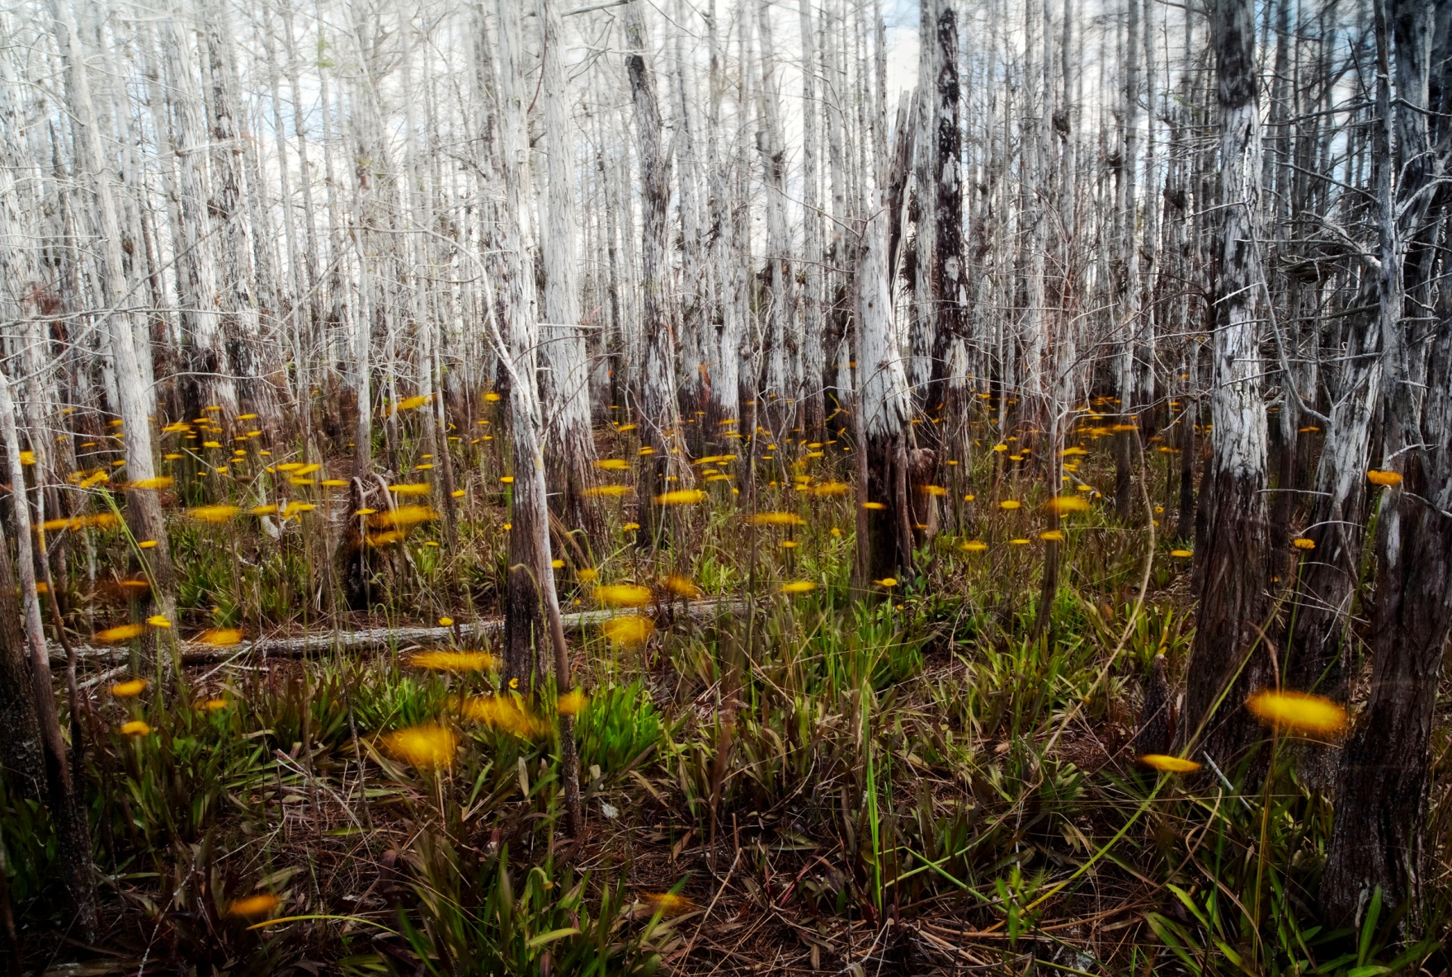
Daisy Dome
2012
Giclee print
16" x 24”
Collection of the Artist
$400

In a world of majestic beauty, I seek to document a more ‘quiet beauty.’ My nature and environmental photography focuses on the many tranquil aspects of my journeys. As an outdoorswoman and environmentalist, I love to explore my surroundings through hiking and kayaking, but I also discover great splendor on my drives through local neighborhoods. I often return to a certain scene multiple times, looking for that one moment to capture its essence. The weather can have a strong effect on my images — low light, overcast, stormy, snowy and foggy days create a surreal effect that reveals unexpected depth.

I have always been attracted to the power of nature’s dynamic landscape and images with strong graphical elements, reflecting a love of the works of Ansel Adams. My photographs demonstrate the results of an investigation of light and shadow, the emotional impact of soft tones and the dramatic effect of sharp contrasts.

Since my very first visit to the Everglades I have been captivated by the vastness and richness of the land and diversity of the wildlife. The feeling I would have was if I had walked back through time -- wild and pristine. The reality is this land is not what it once was and it is still endangered. There is no other environment like the Everglades in the world, a habitat completely controlled by the flow of water.

In February 2012, as a selected Artist-in-Residence for the Everglades National Park, I was able to continue my journey documenting this ever changing landscape. It has been my goal to capture the spirit of this land and its habitants -- tranquil in its quiet beauty.

Willie Baez

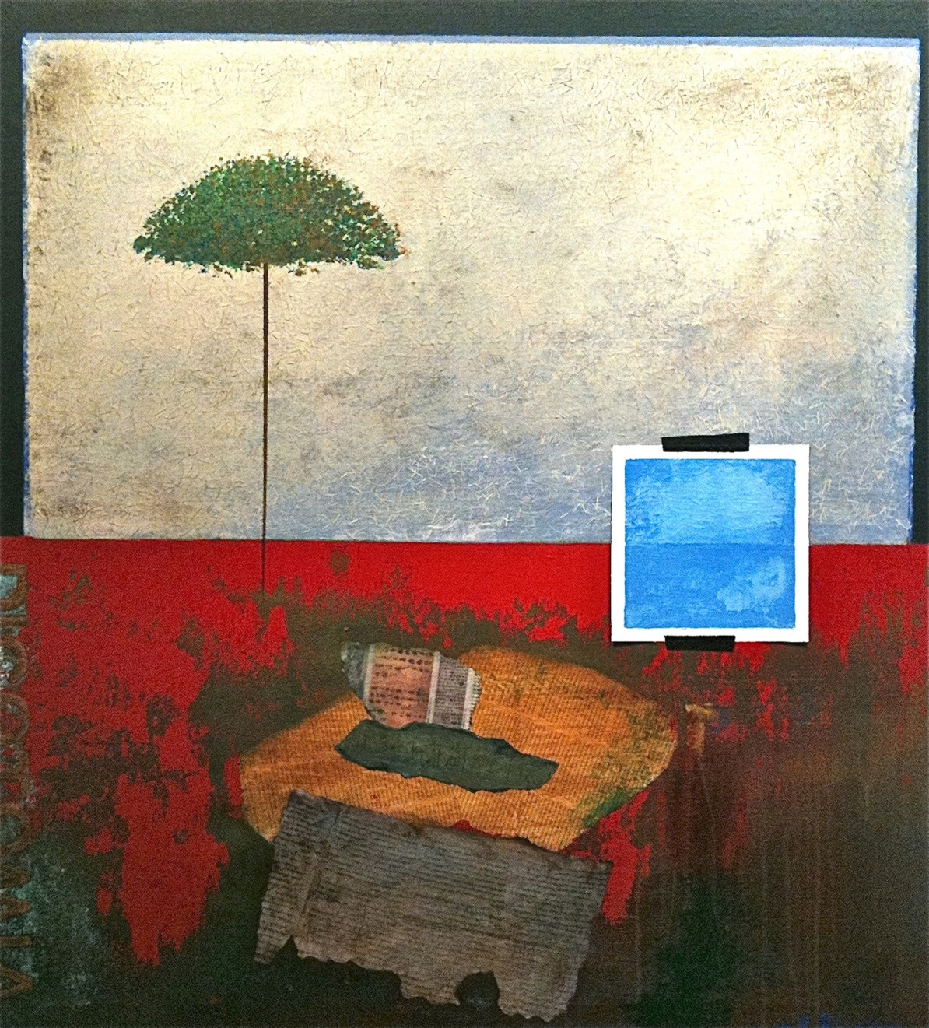
Consciousness
2009
Acrylic and collage on canvas
37” x 34”
Collection of the Artist
$1,200

My relationship with reality and my dreams form the arena that inspires me to paint. It is the mystery of life which intrigues me, as does the furtiveness of the natural world. To explore these mysteries, I have chosen the influential power of paint and collage as a means of expression.
Influenced by many of the European Surrealists of the early 20th Century, Consciousness is a representation of the clear and peaceful ethereal space where our thoughts and ideas are born. This is represented by the inset image that appears to be taped to the canvas (“conscious mind”). I collage preprinted text to my work, often in different languages, to give my paintings the power of idiomatic expression. The “word” often inspires me to paint, creating an entry way where I translate my thoughts into visual images that involve the viewer into my world.
Painting allows me to smooth out some of life’s crudeness; to realize peace and tranquility. I’m a firm believer that as creative beings, we have to continuously convey hope and innovative ideas – if only through the literal as well as visual depiction. I celebrate life and nature. I uncover my soul and spirit and I invite the viewers to reveal their own.
Kiyomi Baird

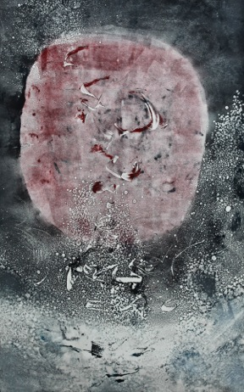
Rubedo
2011
Monotype on paper
38” x 26”
Collection of the Artist
$1,500

Giving Voice is the essence of art. It is the process of self-discovery. It is the path through transformative self-actualization. It gives the self its voice through time connecting the infinite with the finite. I have taken the liberty of incorporating the title in haiku verse as follows:

RUBEDO, reddens
born from the deep darkening
becomes white then gold
Serena Bocchino

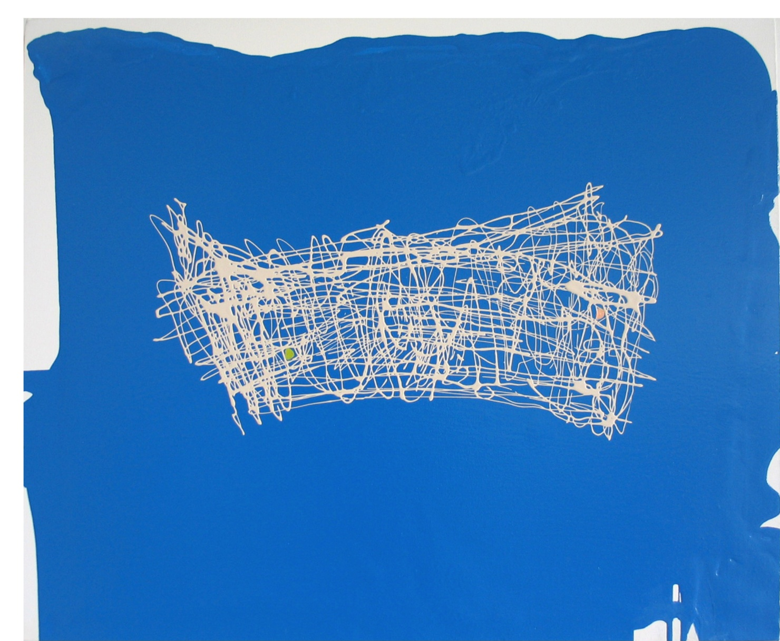
Mind Float
2007
Enamel and oil paint on canvas
28" x 32”
Collection of the Artist
$3,000

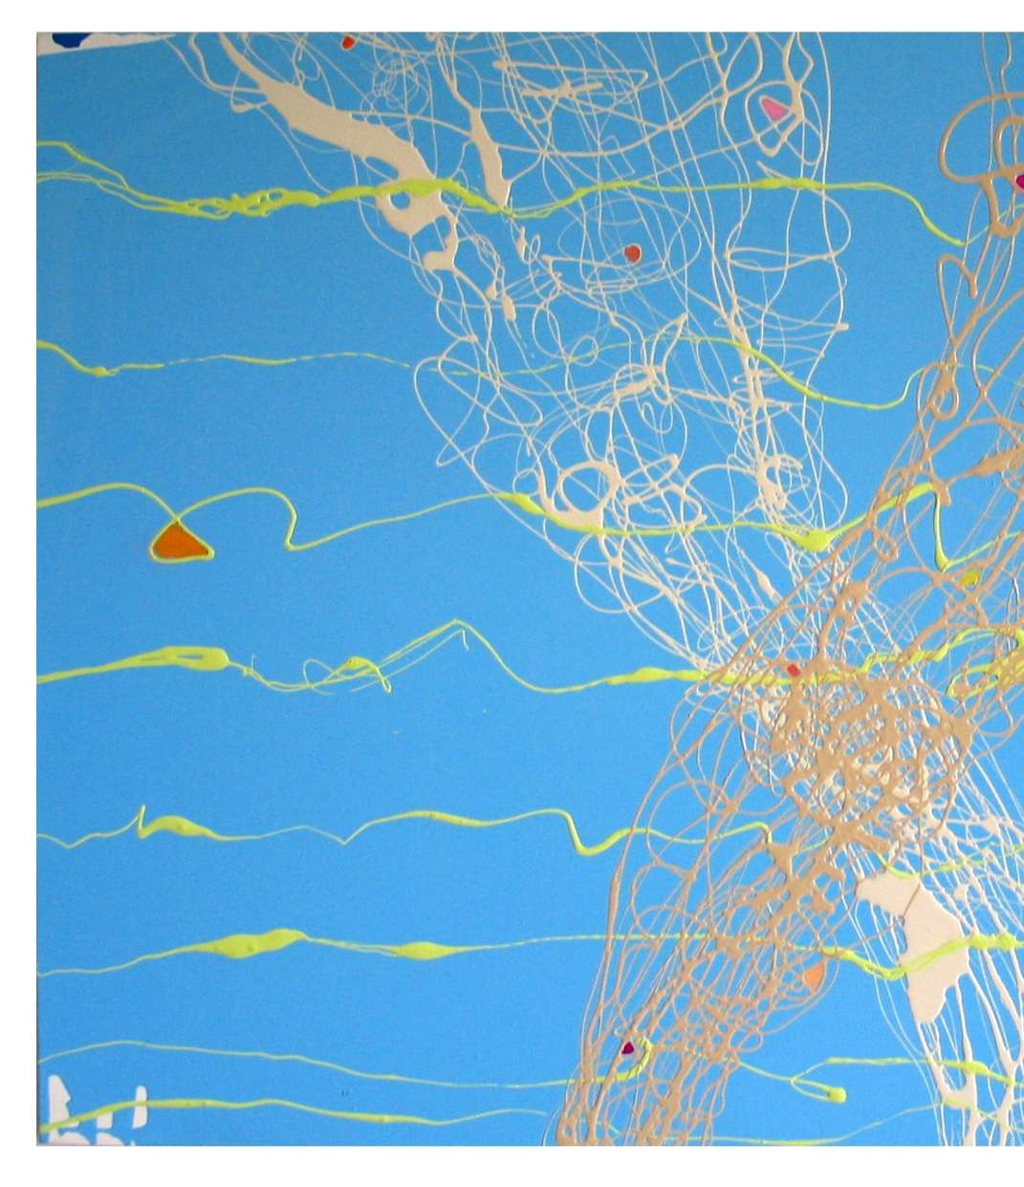
Catch
2006
Enamel and oil paint on canvas
38" x 48”
Collection of the Artist
$4,800

It is about waves… nets … fishing … skies…
fountains...and catching things, fish, ideas, dreams...
It is also about color theory and blues and a variety of whites in relation to blues...it is about transcending imagery into emotive marks and lines.

It is about the music that resonates over the water. It is the beat of jazz as it hits your soul.

These works are images of sound using paint. This series is a visual interpretation of musical compositions and the flow of sound the dynamic of music as it may be seen.
It is about lines and rhythms.
It is the bare essentials of painting and at the same time the fullness of painting.
Vincent Buchinsky

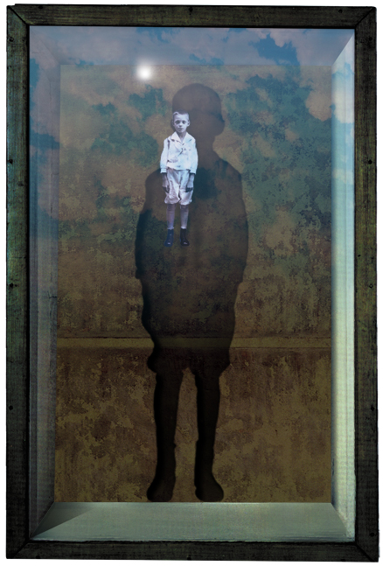
Orphan of the World
2000
Ink on paper
20” x 16”
Collection of the Artist
$100

I watched my mother die when I was fifteen years old. This had a lasting effect on me and is when, I believe, my chronic depression began and set a particularly consistent dark tone to my “voice”.

Orphan of the World was created in 2000 and is a good example of that. It was created right after the death of my father. The child portrayed in the work is from an actual photo of my father when he was about six years old. The emotions elicited by Orphan of the World are what I think my father experienced during his life.

Though this is an image of my father, it is also a self-portrait. At the time that I created it, I was troubled by a sense of depersonalization and, as always, I tried to give form to my emotions. My father’s image is seen through the influence of my psyche, in that he is standing in the landscape of my feelings. Perhaps this can be interpreted as a spiritual link between us.
Fred Cole

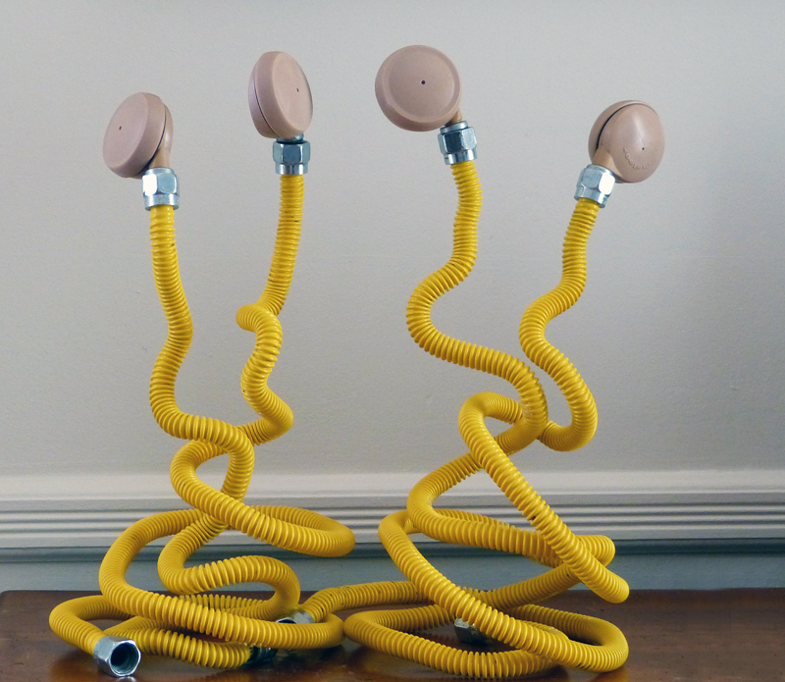

Arranging to Meet

2012

Recycled gas connectors and furniture pads

14” x 12” x 8”

Collection of the Artist

$200

As an artist who works almost exclusively with recycled materials, it is often the material which determines the nature of the work. In a consumer-oriented society such as ours, a “throw away the old, buy the new” mentality exists. This leaves ample sources from which I find materials that already have shape, color, texture and perhaps style, as well as a cultural context in which they have previously existed.

My favorite moment in developing my sculpture is when my mind and eye meet materials and I begin to imagine for the first time how the image may unfold and what meaning it may create. Repurposing material for artistic expression is certainly not a new concept. The use of these pre-existing materials however, lend themselves to the creation of the three dimensional images I produce.

Such an image is my work Arranging to Meet. The flexible, grooved, yellow gas line hook ups, and the “outer-space” like furniture casters quickly came together after I procured them at the same garage sale. They help create for me, figures that share the tangled web of feelings and projections we arrange within ourselves as we arrange to meet others. These figures are very close, yet their shimmering distance is palpable. They want to meet, they are arranging to do so, but can they imagine how their similarities and differences may actually attract.

As a teacher of young children for over forty years, I was consistently amazed and amused at the connections the young make with one other. Equally interesting is how they may make something of nothing that occupies them for hours. Their elaborate imaginations, fueled by inquisitiveness, are often on display. As we age, we tend to funnel our lives into the day to day, as the imagination we knew is slowly tucked away.

It is my hope that Arranging to Meet stirs a memory of childhood friendships beginning and blooming and that these memories help us make laughing, loving friends today: friends with whom we search slightly unchartered territory and the mystery of imagination that quest may hold.

I have also enjoyed partnering with my friend David Weissmann as we present his poem “Men in their Sixties” in conjunction with my own work. David speaks of the contradiction of aging, yet moving ahead with one’s deepest pursuits, while exhibiting what might be called a pugnacious grace.

Men in Their Sixties

1
The small black ball
went whappity-whap
on the concrete wall
while the Atlantic Ocean
peddled, as always,
the same emotion.

2
This morning I got my hair
cut very short and looked
in the mirror at
my nose, bigger now,
and my grave jowels,
older somehow.

3
Old Jewish men,
probably all uncles,
playing handball
at Orchard Beach
whipped the young guys
with no trouble at all.

4
When somebody dies he leaves
an estate sale behind
where, we find, everything
comes apart
only to come together
again, like old men.

5
Look what you’ve made:
the see-through eye,
interrupted connections,
and sprouts of hair
wheeling and dealing to
go, once more, somewhere.

6
“Banish Misfortune”
played our friends
with guitar, flute, fiddle and bow.
Jameson flowed like salve.
What a talented town
we have!
Pasquale Cuppari

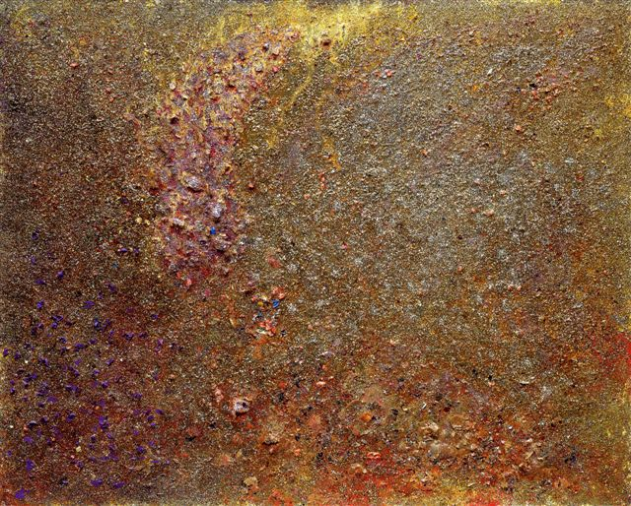
Fuori Dell’Ombra
2010
Oil enamel and mixed media on canvas
48" x 60”
Collection of the Artist
$14,000

“I was brought up by Imagination,
I always travelled by her hand
And thus I always loved, hated, spoke, thought,
Having every day this window before me,
Every hour being mine in this way.”

For me, this fragment of “Time’s Passage” by Portuguese poet Fernando Pessoa describes the joy, excitement, struggle and discouragement that one finds in the act of creation, whether it is composing poetry, music or painting, all of which I have done. My 2010 painting, Fuori dell’Ombra, Italian for Out of the Shadow, is a metaphor for every time one emerges from darkness or struggle of any kind and really ‘sees’ or understands what they are looking at. Pessoa is saying that it is a blessing and a curse to have insight and time for creation. In Fuori dell’Ombra, I am celebrating the ecstasy I feel when I paint. And in response to Pessoa, I wrote:

Furori dell’Ombra
into sunlight;
travels in dreams,
shadows fade.
Liz Demaree

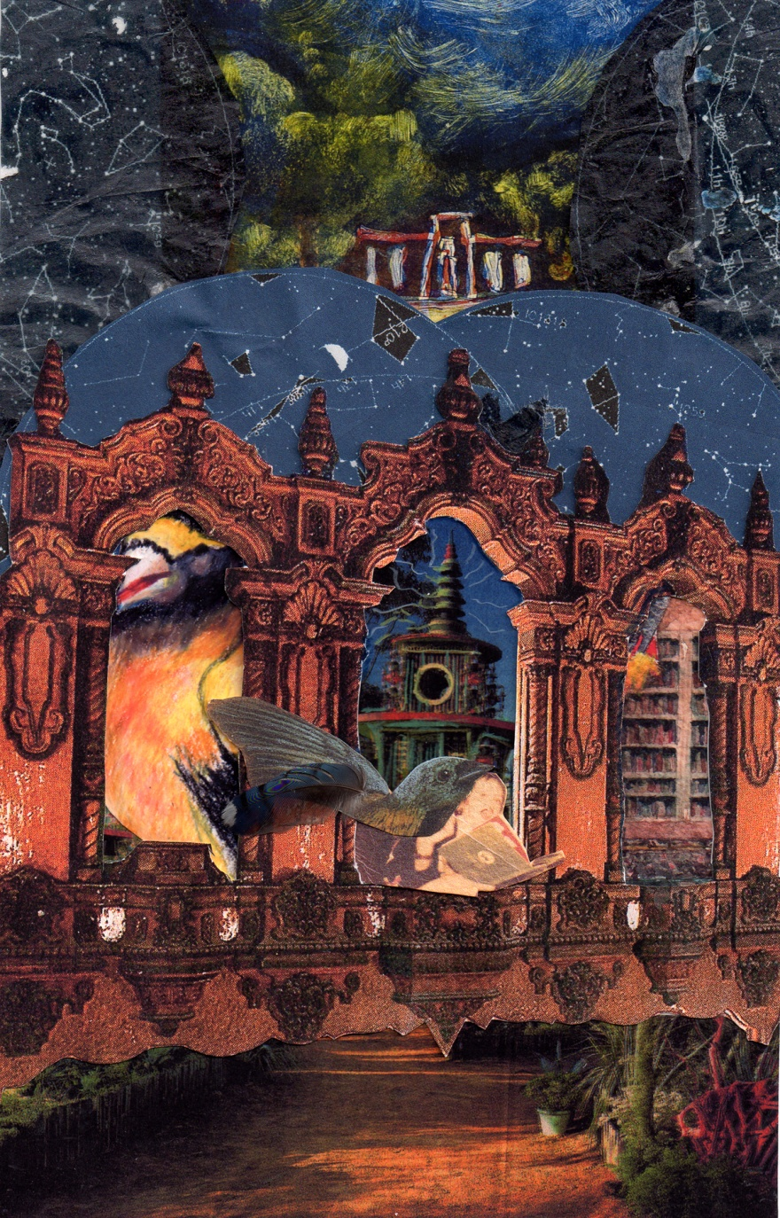
My Childhood Imagination
2012
Mixed media collage on paper
11” x 17”
Collection of the Artist
$350

When I read the excerpt from “Time’s Passage”, I immediately thought of my childhood and how I used my imagination then. I knew by the time I was 5 that I wanted to be an artist when I grew up. And I think that my imagination is one of the strongest implements in my artistic toolbox.

I have been making mixed media collages for the last year. What started as a simple exercise to get the creative juices flowing has become somewhat of an obsession with me. I found myself using bird-headed people in several of my earliest collages, and these prompted me to start a story about these mixed DNA people. I’ve also spent much of my artistic career painting pictures of houses, making dioramas of rooms, and creating wallpaper from patterns in nature. So I decided that I would use these elements to symbolize my own imagination and how it responded to the beautiful words of Fernando Pessoa. It was quite a different process to take someone else’s words, and create images to complement them, rather than the other way around. I must admit it was quite a challenge, but one that I enjoyed immensely.
Buel Ecker

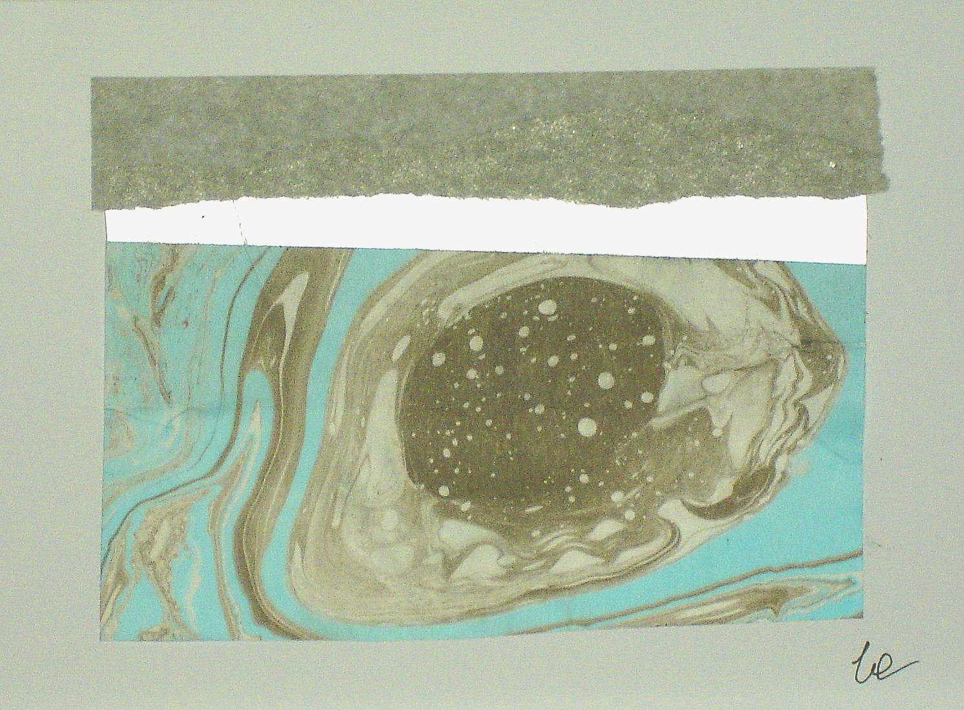
After I Left the Sea
2011
Suminagashi ink on paper
10" x 11½”
Collection of the Artist
$300

The imagination that brings about poetry and art often collide and mix. Either art form has the power to make alive and tangible invisible thoughts. So many times these productions-of-our-souls give rise to visions that speak from an internal force allowing universal truths to be seen, heard and shared.

Suminagashi is the Japanese version of marbling. Originally, suminagashi was used to decorate the paper on which the nobility of the Heian Era (794-1185) wrote poems. Other cultures, most notably the Turks and Persians, adapted and used this method with variations to suit their own aesthetics and needs. By the 17th century, marbling had spread into Italy, England, France and Germany and was mainly used by book binders for end papers.

Intrigued by this art form, I have spent the past two years exploring, experimenting and expanding the original suminagashi methods and materials. The resulting pieces abstractly reflect the freedom of movement found in nature’s characteristics and patterns. This ancient method leaves limited room for control but is rewarding as it produces unique, singular images that remind us of the beauty and mystery of life.

Dan Fenelon

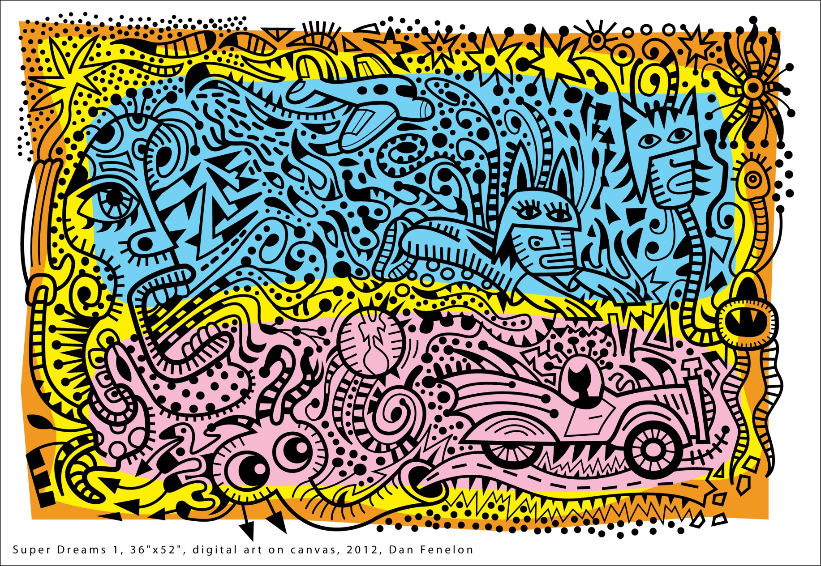
Super Dreams
2012
Giclee print on canvas
36" x 52“
Collection of Artist
$2,000

My art infuses a blend of pop, cartooning, modernism and tribalism along with an explosion of vibrant colors. Cartoons were a big influence on me growing up. My formal education at the School of the Museum of Fine Arts allowed me the time to develop a deep understanding of the history of art through the ages and had a profound impact on my own personal style. Fusing these different ideas together has become the foundation for my art. I do feel the need to push myself further so I continue to study and work at keeping my art interesting.
Carlos Frias

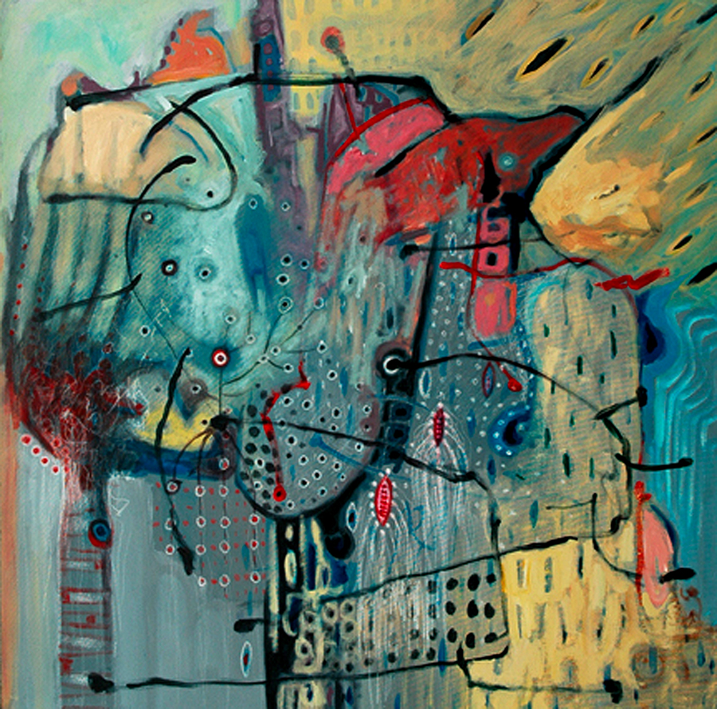
Seeds
2010
Mixed media on paper
30” x 30”
Collection of the Artist
$1,100

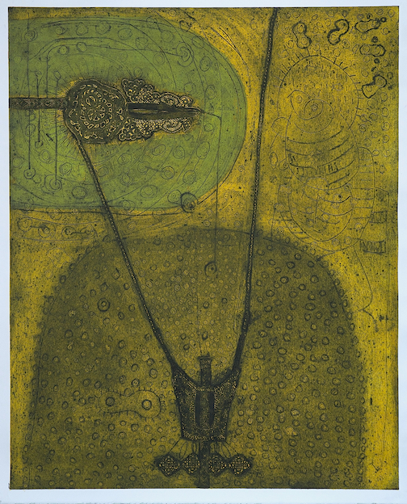
Legacy
2011
Collograph on paper
42” x 35”
Collection of the Artist
$1,800

My most recent works are all part of a larger puzzle which, once completed, will form a spatial creation myth. In my pieces, I explore humankind as a microcosm, represented by its most elementary components, through its continual development, toward what we are to become as a species.

Some of my art attempts to strip us of our spirituality and our culture, representing us as organic forms bound to decompose and regenerate. Works from this same series highlight our humanity - our creativity, our relationships, our urge to grow, and at times, to self-destruct.

My creation myth has been years in the making and is not yet complete. I continue to visually exemplify the parallel between what art is able to represent of the evolution of humankind and how much we want to preserve and manipulate art to represent the history of our species.

Kathryn Keller

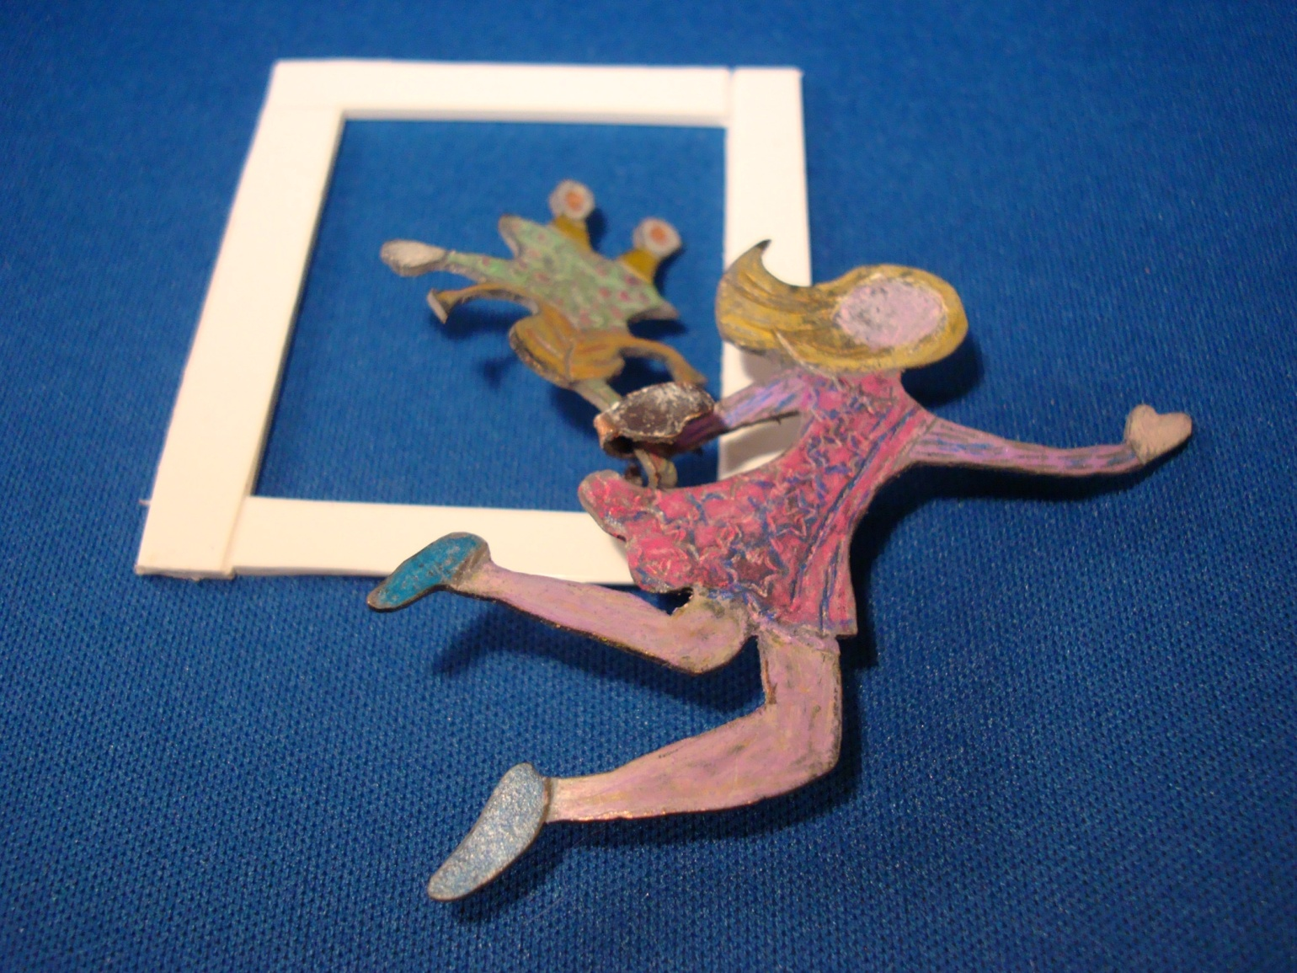
Flight of Imagination
2012
Color pencil on copper and pvc
6” x 8”
Collection of the Artist
$125

I wanted to capture the moment when our imagination takes hold of us. The little girl has been waiting by the window, day dreaming. Imagination takes her by the hand and pulls her through the window to an awaiting adventure.

As I reread Fernando Pessoa’s poem and looked at my emerging piece, I realized that I had created the narrator of the poem as a little girl much in the images of my daughters when they were toddlers. Imagination took the shape of a young woman which I came to understand as me as a young mother. Oh, the lovely times we had making up plays and stories, drawing and painting.

One more reading of the poem revealed what my unconscious was saying. The title of Pessoa’s poem is “Time’s Passage.” At first the concept of time passing made me sad. I will never again able to experience those wonderful days. However, I can reach back into my memories and relive them. More importantly, I realized that passage does not mean the end. My little toddler is now herself a mother with a little girl. They make up stories and draw and paint. So imagination has not ended but has passed along the continuum of mother to child, mother to child.
Jessica Lawrence

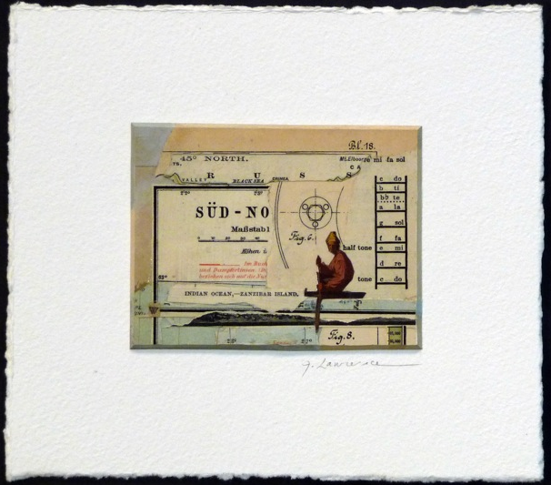
Sud-No
2011
Collage on mat board and watercolor paper
7½” x8 ¼”
Collection of the Artist
$350

Sud-No is a window into an imaginary world where the mysterious protagonist navigates the sea-sky line through floating islands of linguistic and spacial ambiguity.
Allan Luisi

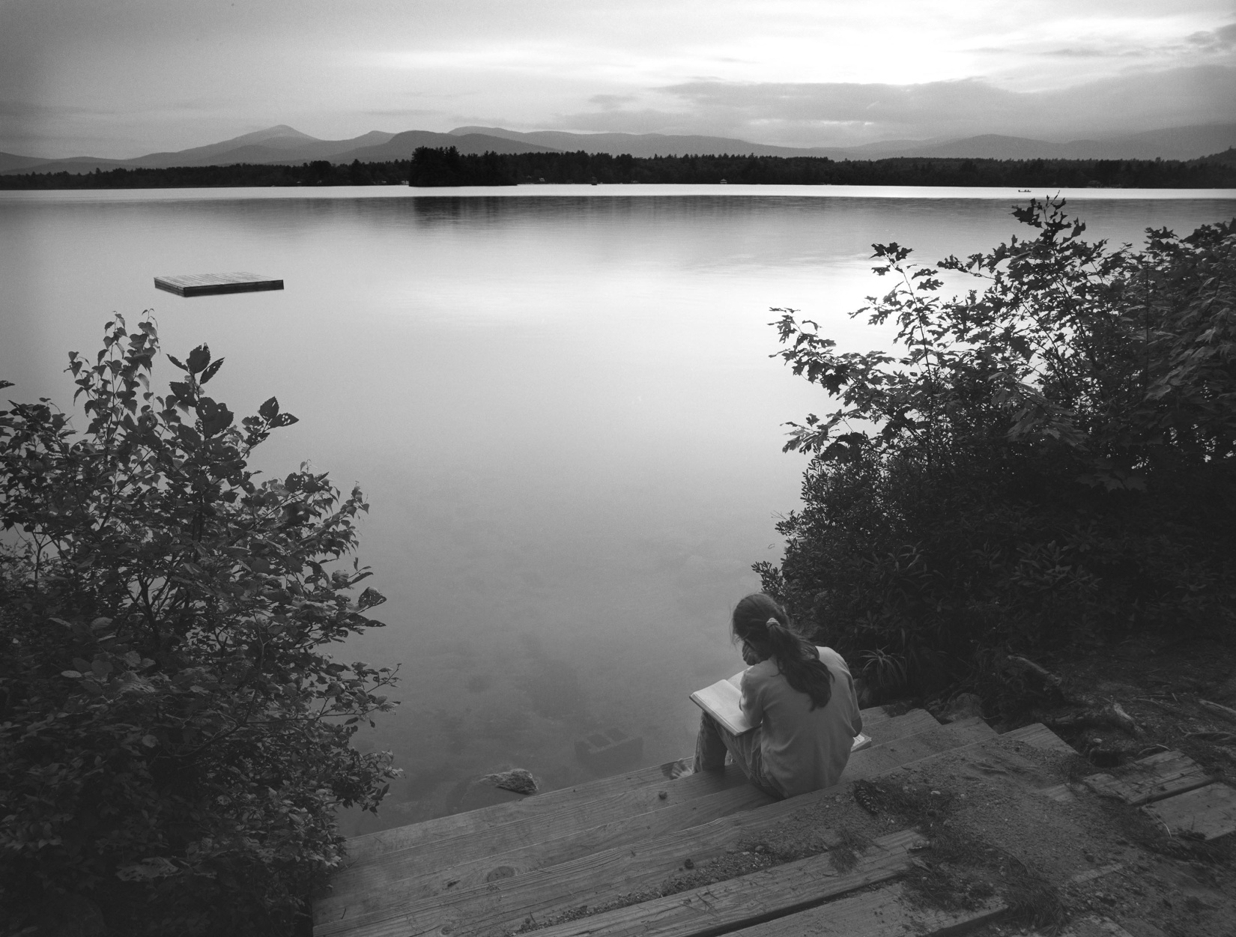
Inspiration
2005
Archival laser jet print
18” x 22”
Collection of the Artist
$200

This image was taken on a lake in western Maine. The inspired young girl I found at the water’s edge is my daughter on a family vacation. It was sunset, very quiet and peaceful; she was writing by herself with this wonderful scene in front of her. My daughter has always been an imaginative person, never too concerned about being conventional. I am sure her imagination was fueled at moments like this (“brought up by imagination”).

Karen Lundquist

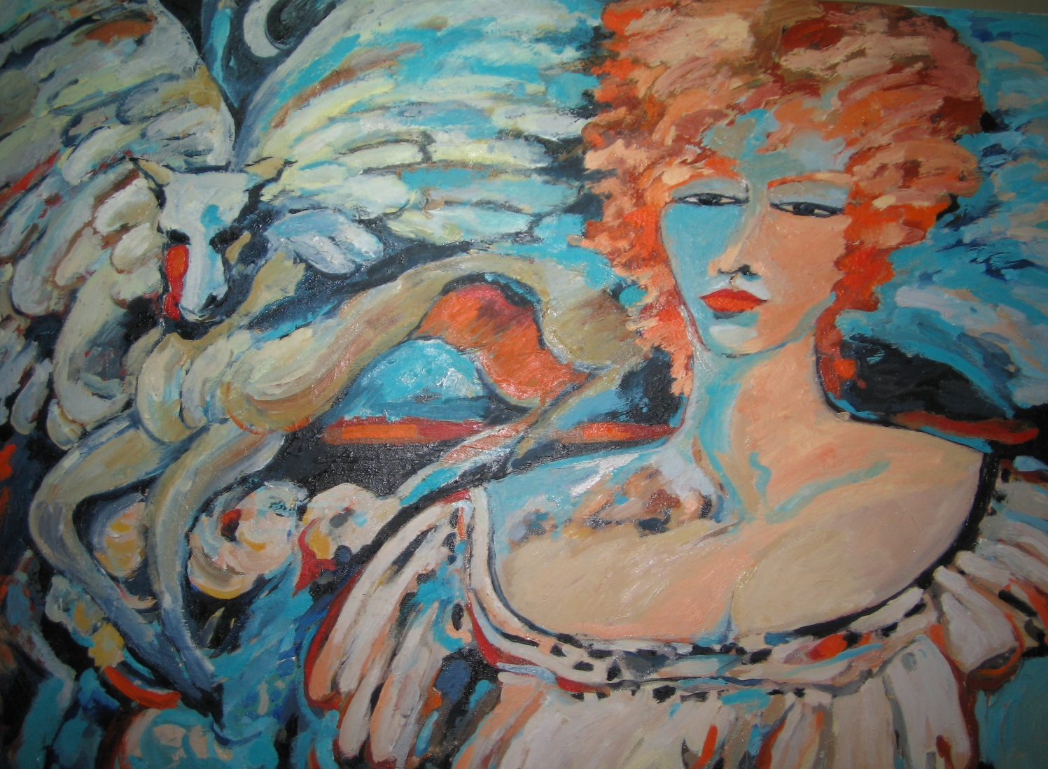
My Pegasus
2012
Oil on canvas
34" x 44”
Collection of the Artist
$1,000

My Pegasus is my personal interpretation of Pessoa’s poem, depicting the critical role that imagination and free rein play for me in creativity.

Pegasus, the fabled winged horse, is my symbol of the fantastical creatures and other beings that can emerge from the artist’s mind when fear is overcome and creativity unleashed. I approach every painting “having every day this window before me” and find that with each painting, more and more of my inner self is revealed… and more and more of the fear falls away.

Patricia Malarcher

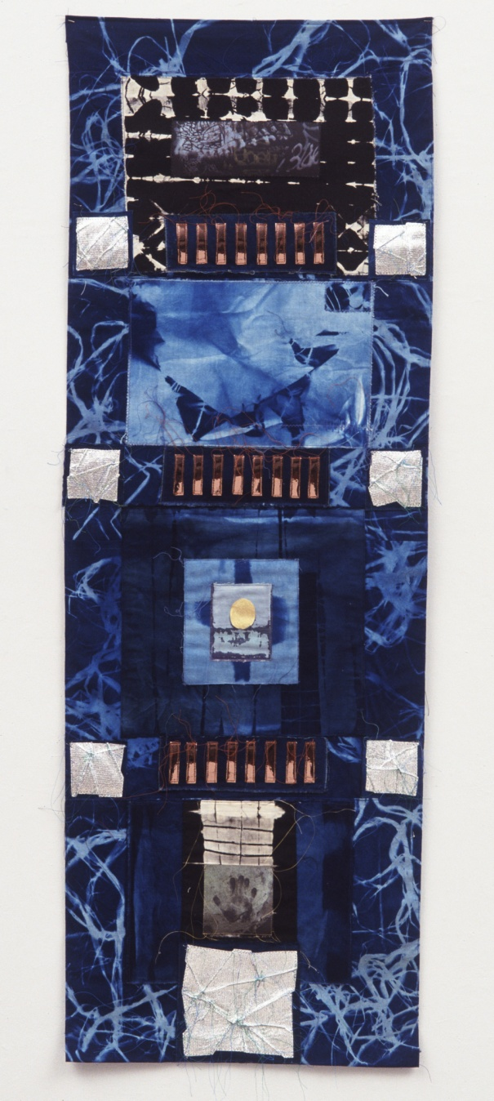
Tides
2007
Fabric, discharged/blueprint, gold leaf, mylar and transfer prints
52” x 18”
$950

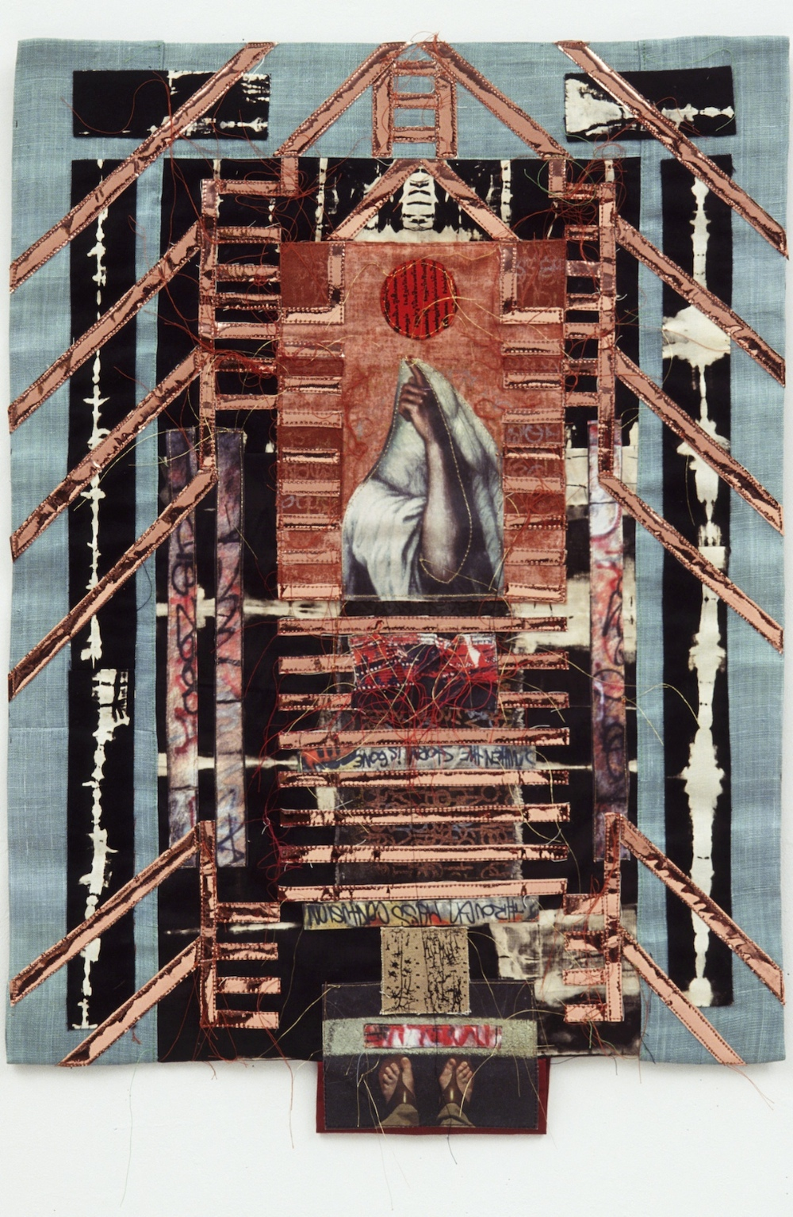
Jacob’s Ladder
2004
Fabric, mylar and transfer prints
25” x 19”
Collection of the Artist
$750

My work often incorporates images of hands as metaphors for aspects of the creative process.

In Tides, the image of a human handprint represents the mark of the artist in an abstract composition. The golden egg form alludes to gestation of an idea.

In Jacob’s Ladder, the beckoning angel’s hand invites the artist to search beyond where her work stands.
Elaine Provost

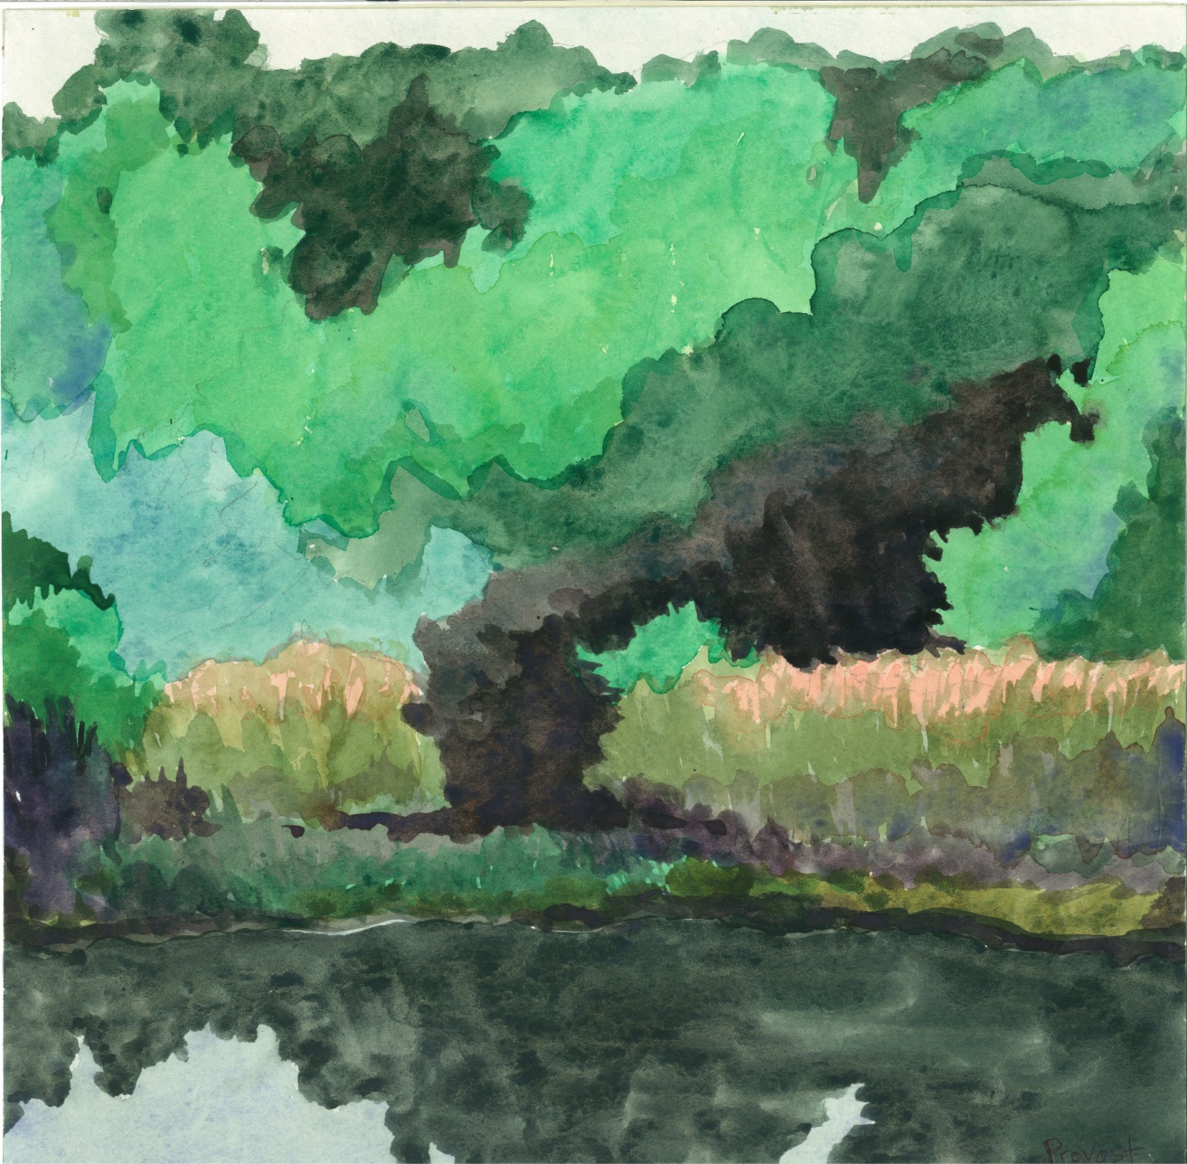
Dark Passage
2010
Watercolor on paper
14" x 14“
Collection of the Artist
$395

I see my paintings, collages and drawings as windows to intimate worlds that draw the viewer in. The window created by my watercolor Dark Passage sparks the imagination, inspiring the viewer to wonder “what is behind those trees and bushes?” It is a moment filled with mystery, opportunity, and surprise. These elements in my work allow the viewer to relate his or her own experience and memory to the images I create.

Larry Ross

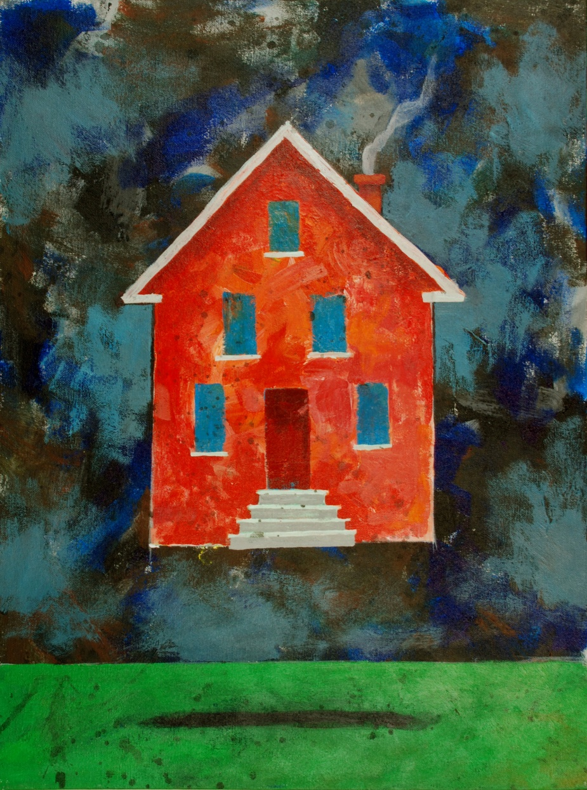
Home Sweet Imagination
2010
Acrylic on canvas
24” x 18”
Collection of the Artist
$450

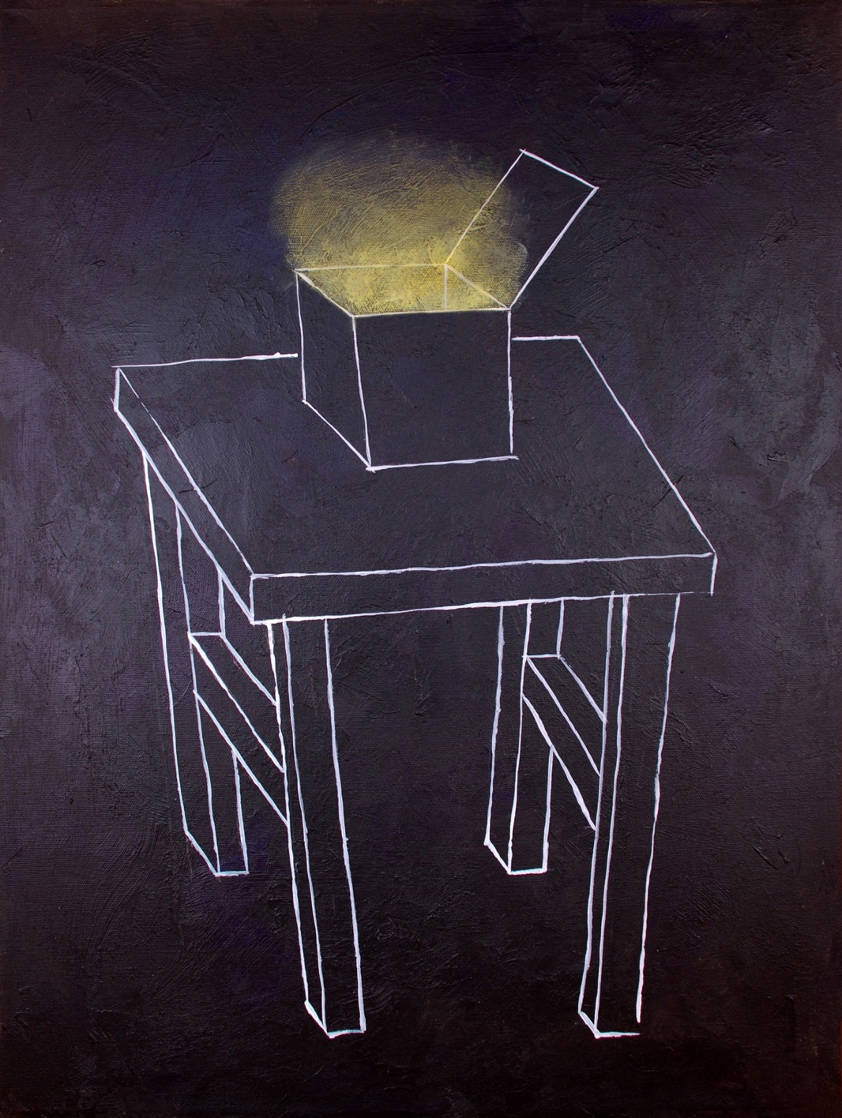
Silent Revelation
2010
Acrylic on canvas
24” x 18”
Collection of the Artist
$400

Home Sweet Imagination is a work of art that I created totally out of my imagination without a preconceived idea of how it would turn out. It represents that special weightless, floating place at the core of my being where my creativity lives and has been nurtured throughout my life. It’s a home that goes with me wherever I go through good times and dark times. It’s the place where I was brought up. It’s humorous and whimsical while being mysterious and unexpected.

Silent Revelation is a work of art that came to me in a dream in the silence of the night. I literally saw it the way that it appears on the canvas with the white lines on the dark background and with the soft glow emanating from the box. The image came together out of the darkness giving me hope and the encouragement to continue imagining. I think the light in the picture will become anything that we can imagine it to be.

Wayne Charles Roth

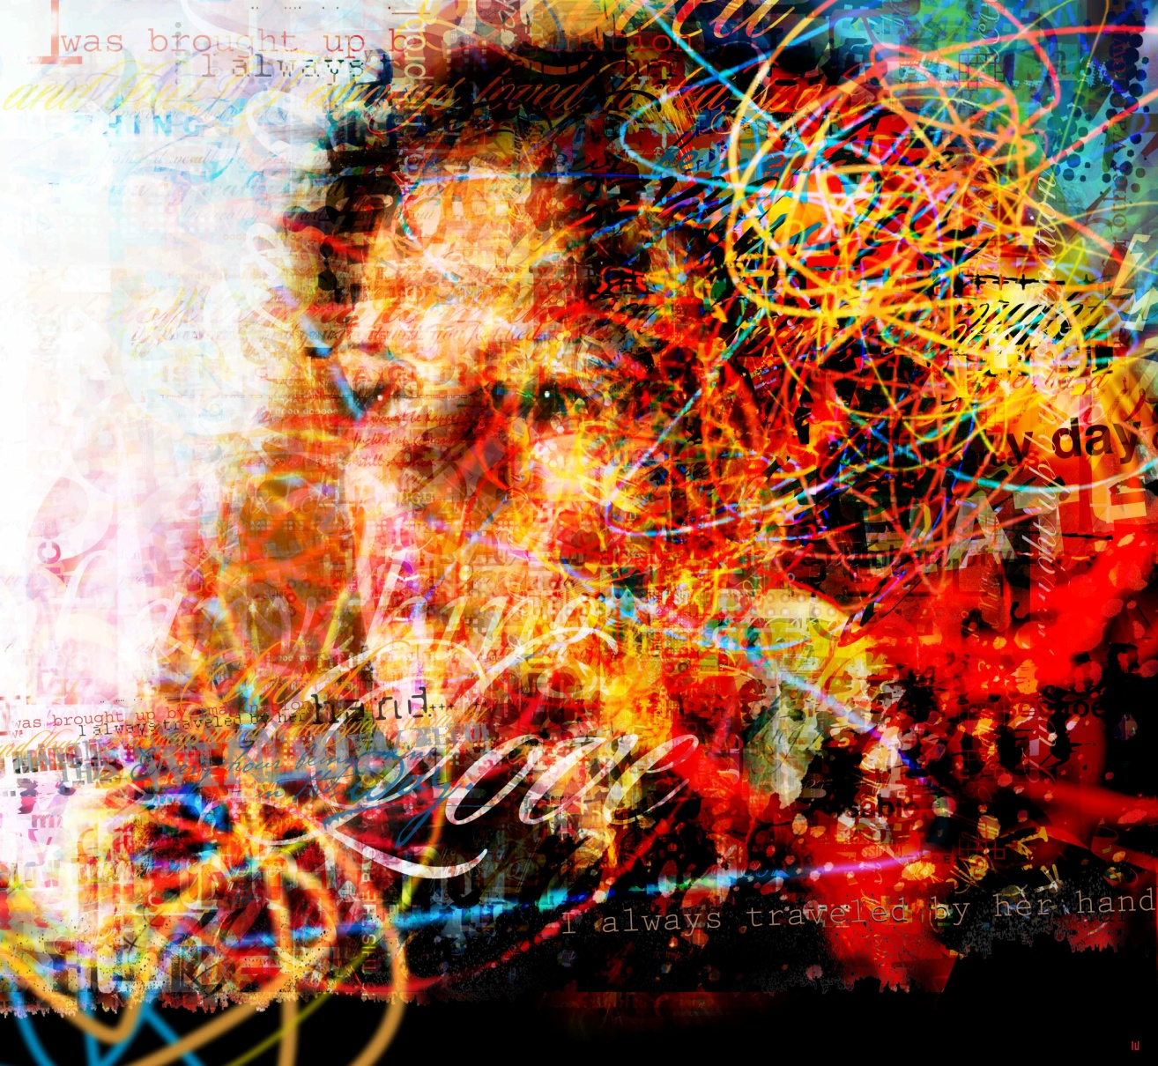
By Her Hand
2012
Print on acrylic
46” x 42”
Collection of the Artist
$4,200

For the last two decades, I have worked as a professional photographer, illustrator and designer for some of the biggest companies in the world including Adidas, Adobe, Ford, Nike, Pepsi, Sony, Time, and many others. I have also had the opportunity to create work for international clients in Brazil, England and Germany as well as Japan, Korea and the United States.

My work has always raced on the edge between fine art and commercial design, tending to attract clients who want to push the boundaries of advertising. About two years ago, my images began to be noticed by more and more art collectors and curators. The opportunity to digitally compose and paint fine art images offers me tremendous creative freedom and has pushed me to innovate and expand exponentially the possibilities inherent in this 21st century medium.

As a photographer, I would work for days preparing for a shoot. The final product would be one frame, one fraction of a second. It was planned and executed to look spontaneous and fresh. This mindset and way of working is ingrained and has profoundly influenced my images and digital painting. All of my works focus on capturing a moment or millisecond, regardless of the subject matter, like a camera that can capture any creative fantasy imaginable. Additionally, it is my intention to create images that have never been seen before.

I am not influenced by any school of thought and my work is not derivative of any other artist’s work. My process is slow and methodical. I have an idea of an emotion or place I want to convey. My inspiration may come from nature, a dream or the media. Everything begins and ends on a computer and is built over the course of three to five weeks. I utilize hundreds of tiny elements, all of which are painstakingly painted over many weeks before I even begin to make the initial composition. Although I have a strong idea or concept of what I want to achieve, I also react to what I see as a work develops, and sometimes it will go in a completely different direction than I had imagined.

My work is heavily layered with detail and meaning. It is important for me to create different levels of viewing for my audiences. I strive to reward everyone who looks at my work from varying distances with increasing levels of complexity, understanding and consciousness. The more you look, the more you will see into my creative vision for a piece. Energy, motion and intricacy are the key elements in all of my compositions. My pieces are unique and have attracted the attention of those with a strong vision for the future and a craving for new forms of expression.
Kiyoko Sakai

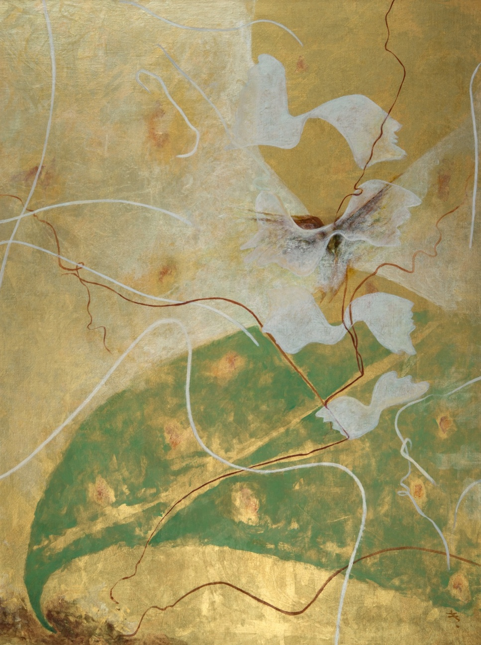
Flight
2010
Acrylic and metallic powder on canvas
32” x 24”
Collection of the Artist
$3,500

The feathers in my work, Flight, symbolize soaring up in the higher realm of the timeless and the boundless. I long to be elevated in the luminous celestial space. Gold and iridescent colors are utilized to represent the rejoicing of my soul and spirit.
Fausto Sevila

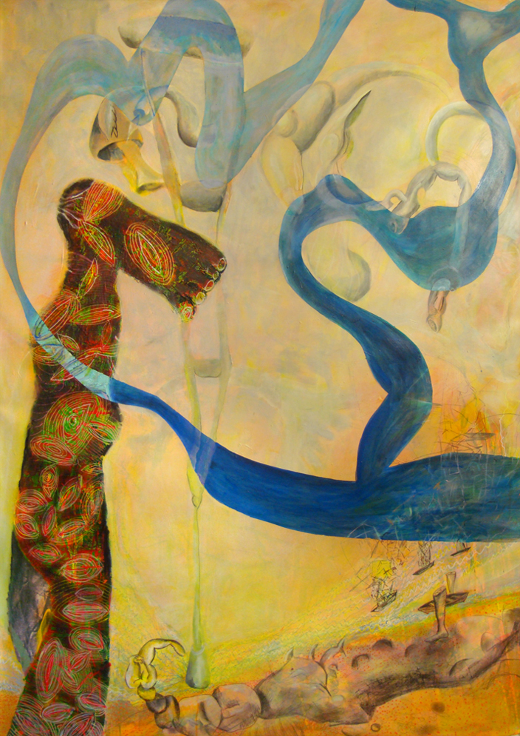
The River in Yacabo Empties Into the Horizon Line
2012
Acrylic on canvas
44” x 60”
Collection of the Artist
$4,000

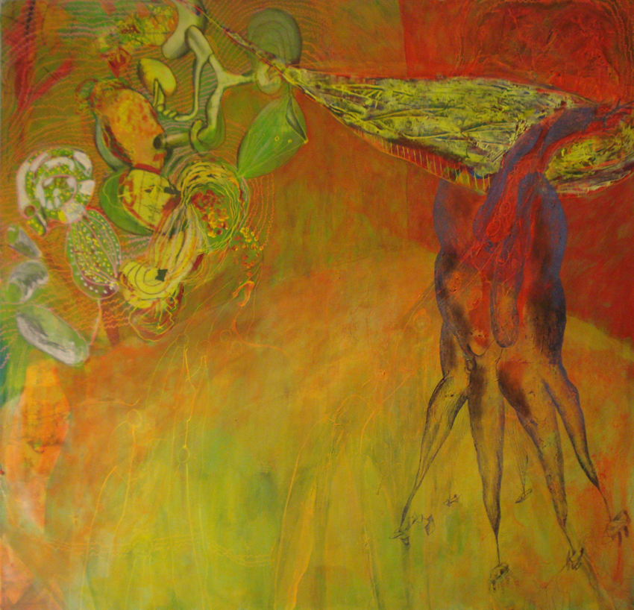
Felipe’s Hammock and the Tricycle
2012
Acrylic on canvas
44” x 50”
Collection of the Artist
$4,000

My paintings have grown from reworking personal narratives through drawings, digital imaging, performances and writing. Like the music in Lorca’s poetry, where the sound takes him where he was not expecting to go, I want the quality of paint to translate and inform the narrative in unexpected ways. All of these layers of reworking serve to tease out and explore unexpected content in the story. Painting gives resistance to conclusions, and tightly woven stories. I hope to complicate the mental space in the process for associative play between the media and the narrative. Like all expressionists before me, I want the narrative to suggest something beyond the image. Like a flytrap I want to press the right sequence of buttons to induce disturbances and ecstatic convulsions. My intention is to include the slower moving body into the intellectual abstractions. To slow down the fire in the brain and make it bow to mud and dying cells. Imagination is a slow moving slug that is not simply interested in puns and solving problems. Imagination is resistance to flight and “personal opinions”. Imagination is a substance that forces you to look down, slow your pace, and avoid cleaver “feel good” ideas disconnected from our body.

Jen Soma

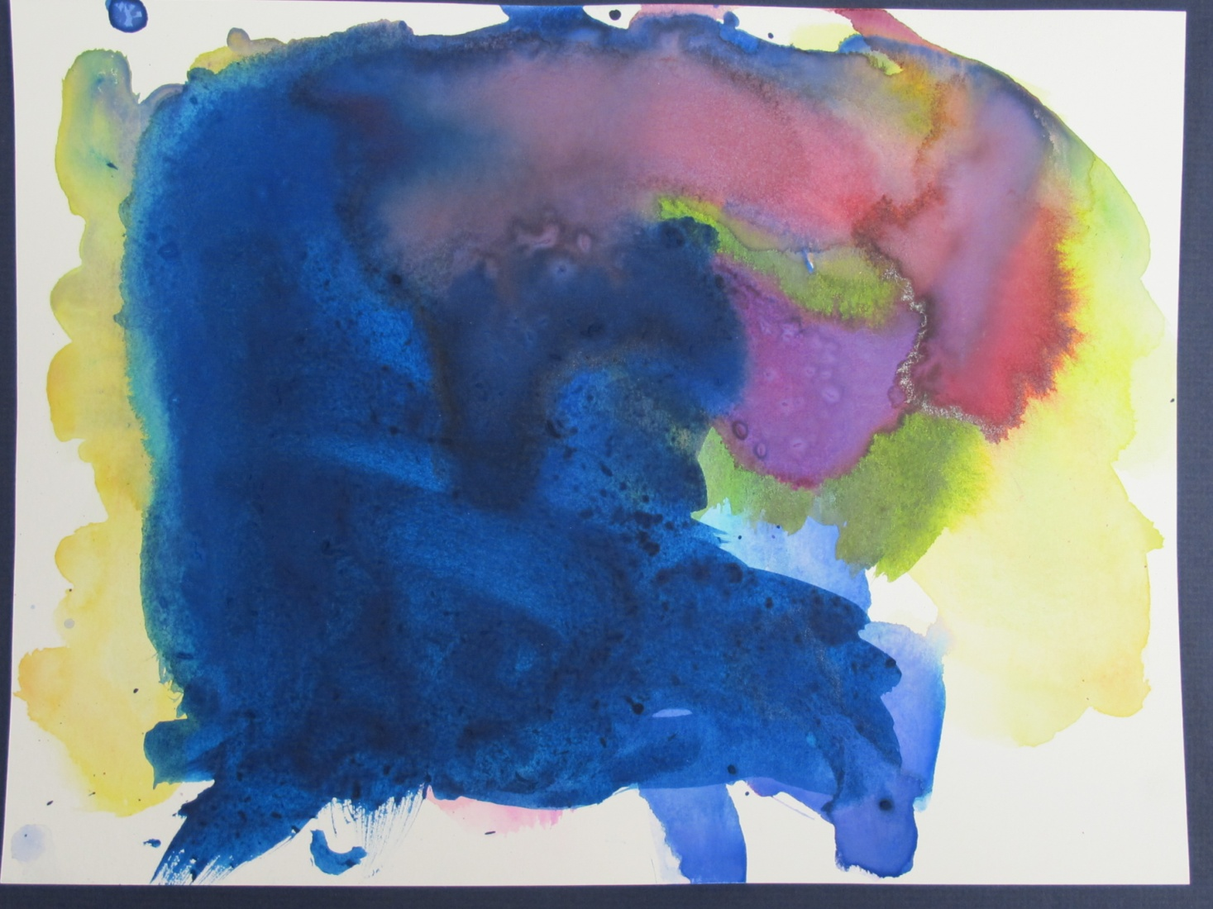
Design Adventure
2012
Watercolor on paper
14” x 18”
Collection of the Artist
$150

I see water.
I see adventure.
I like the design.
I see lightning.
I see a rainbow.

Sandra Styer

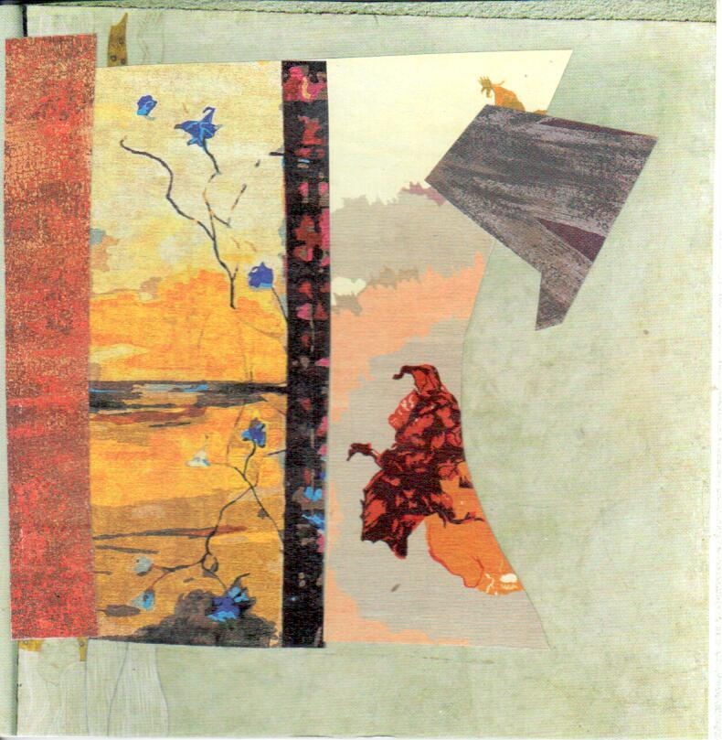
Kyoto Autumn
2012
Paper collage on bristol
12” x 14”
Collection of the Artist
$300

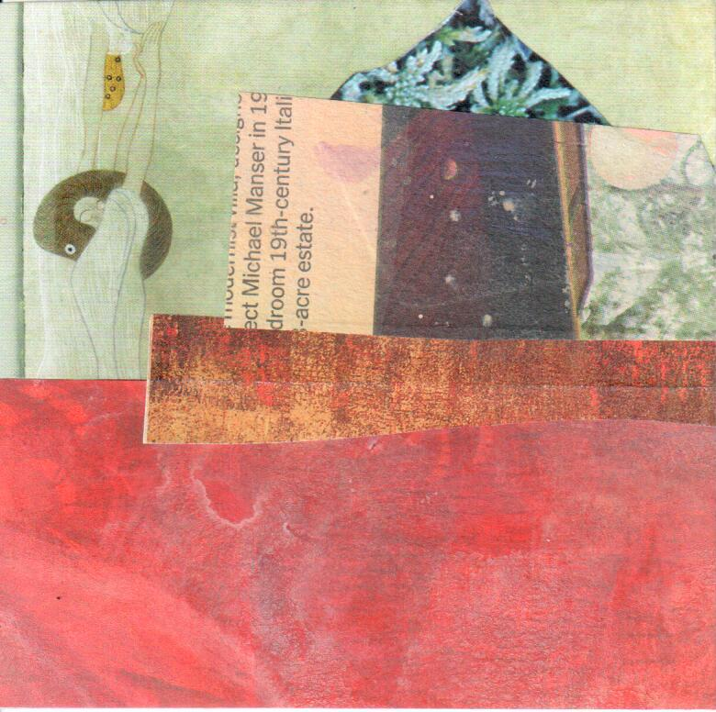
Little House
2012
Paper collage on bristol
12” x 14”
Collection of the Artist
$300

“I was raised by Imagination ….”

This magical line captured my imagination, as the image came to me of a wraithlike mother dancing through dark woods and swirling around bright meadows, opening doors and pulling us through. Perhaps she came from The Little House or danced through the woods in Kyoto Autumn.

All of collage is for me, a dynamic and mysterious art form, a constant act of imagination. I start with the materials and let them tell me where to go. No collage ever comes out where I think it will. I work with hand-painted papers, found papers and little bits of this and that to create works that have a sense of beauty and a sense of mystery. My hope is that viewers enjoy looking at these pieces over and over, and keep uncovering something new.
John Tetz

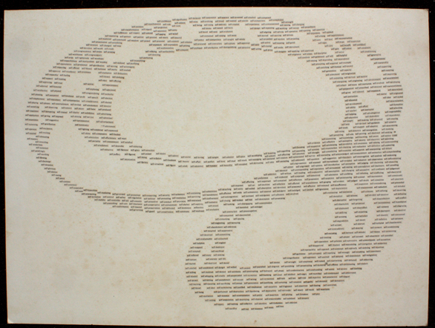
Self
1979
Ink on paper on mat board
30” x 40”
Collection of the Artist
Not For Sale

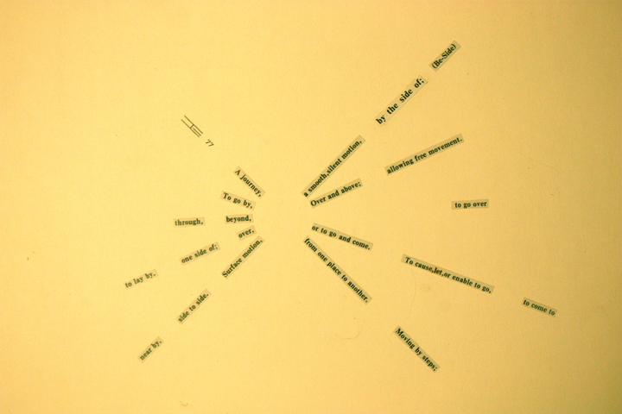
Be-Side
1977
Ink on paper on mat board
11” x 13”
Collection of the Artist
$100

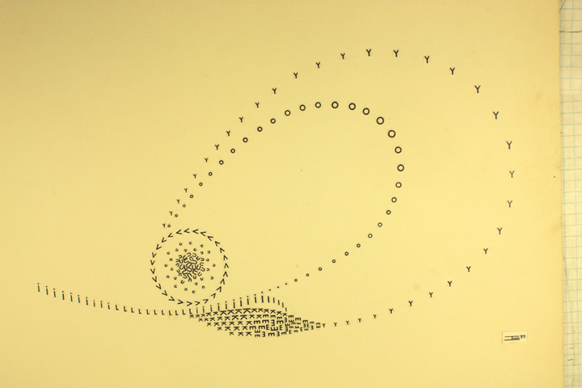
Like & Love
1977
Ink on paper on mat board
12” x 15”
Collection of the Artist
Not For Sale

My art grows out of some basic concepts. I am fascinated with patterns that emerge in all areas of life, be it language, movement, or letters of Nature. In each of these three works, I explore a different type of pattern.
One deals with sentence fragments radiating around a central core space while another explores repeated letters both spelling out words and creating meaningful geometrical shapes.
The largest one delves into the repetitive patterns of the prefix "self-," interconnecting words with juxtaposed meanings. The overall shape was generated by these relationships.

Linnea Tober

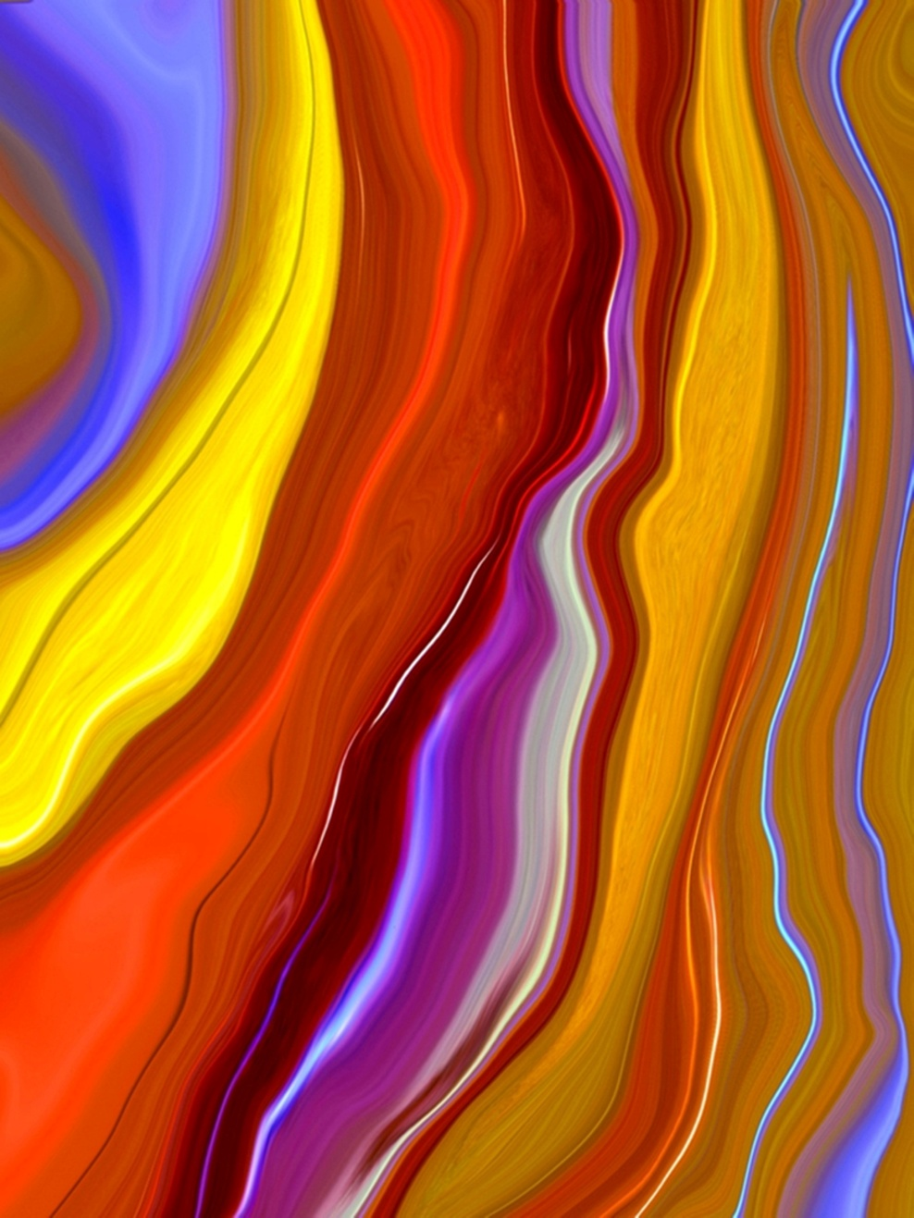
Emerge
2012
Photographic print on canvas
16” x 20”
Collection of the Artist
$250

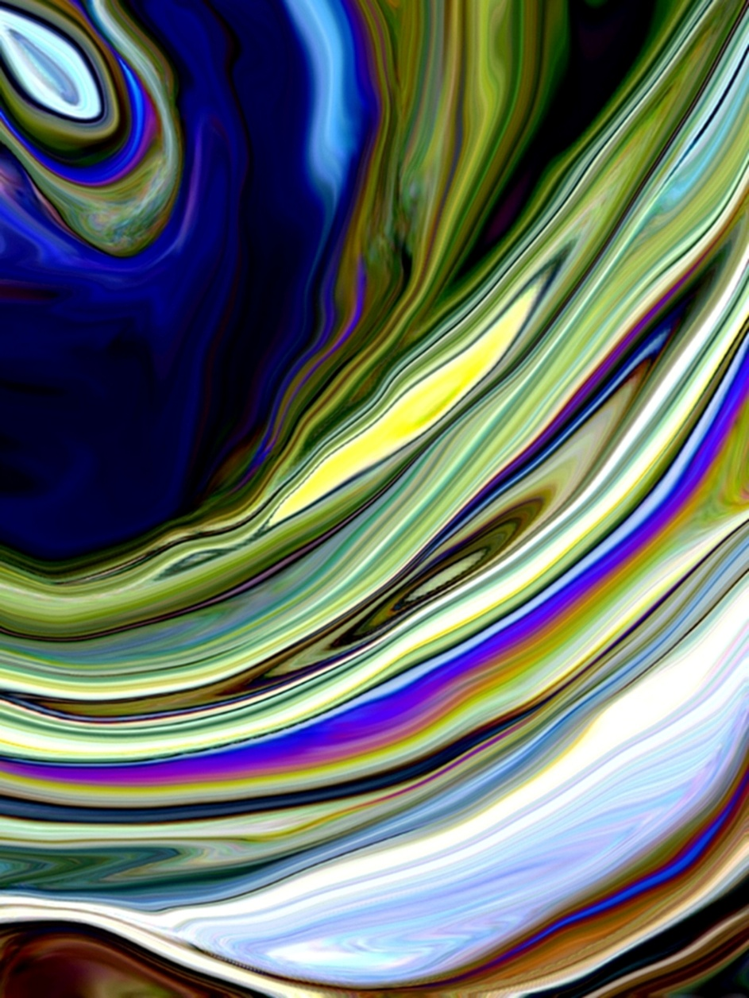
Eye of the Storm
2012
Photographic print on paper
20” x 30”
Collection of the Artist
$350

"Imagination is more important than knowledge. Knowledge is limited. Imagination encircles the world."
-- Albert Einstein

I can remember as a child always being called “imaginative” and “creative.” I knew even then that those words were compliments; they made me feel special and unique….and I was a child who always wanted, more than anything, to be unique. So I lived my life being “imaginative,” and wore it like a badge of honor.

We are all creative beings, artists. Every one of us has the innate desire to express what is inside of us. Creating art is my way down the rabbit hole, my salvation. Bold colors and unique textures consistently find their way into my work. I approach photography with the eyes of a painter, a colorist, and I use my imagination to determine what my photos will become, what they will morph into, what their second life is meant to be. My photography works focus mainly on nature, the intricate textures, shapes and shadows she creates on her own. I shoot those images, always thinking of what they can ‘become. I then twist and tweak them to make them my own “nature photographic abstractions.” Sometimes you can see the original image and sometimes not; it all depends on where the muse takes me.

I shot the Emerge photo, which began life as a tiger lily flower, with this exact creative approach in mind. The colors spoke to me as did the flower, but I knew that I could transform it into something bold, powerful, vibrant and flowing. That was my desire in creating Emerge - to bring the already natural into an even more natural, organic and flowing image.

With Eye of the Storm, I shot the image of the ocean along the Jersey Shore, right before a storm. It was dusk; the sky was turning a deep cobalt blue. The waves were crashing and the sounds and scents of the beach were amazing, exhilarating. I captured many shots of the ocean and the sky that night but one in particular one spoke to me. I chose the one where the cobalt blue was the most extreme and brilliant and went with it. I created my abstract, trying to keep the movement, the drama and the vibrancy of the ocean during a storm in my mind’s eye.

In other words, I used my imagination to manipulate and “paint” the abstract works that are in this show.

This is what imagination does….it not only encircles the world but it comes and sits softly on the artist’s shoulder, peering over and watching us, guiding our strokes, our color choices, our shapes and above all, our creations.
About the Curator

Margaret O'Reilly is the Curator of Fine Art at the New Jersey State Museum in Trenton. She joined the State Museum staff in 1988, and took on the curatorial role in 1997.
At the State Museum, Ms. O’Reilly has organized over 85 exhibitions including a complete re-installation of the Museum’s art collection – American Perspectives: The Fine Art Collection; the critically well-received exhibitions, Reality & Artifice – New Jersey Arts Annual: Fine Art (2010), Transcendent: Toshiko Takaezu in the State Museum Collection (2009-10), Women's Works (2002), and Mel Leipzig: A Retrospective (1998); as well as Vision & Voice: Artists in Dialogue with Contemporary Poetry (2005), and a number of New Jersey Artist Series exhibitions.
Ms. O’Reilly received her MA in painting from Kean University, and her work has been included in numerous exhibitions in the region. Her research and exhibition interests echo those found in her own creative output and include issues of chance, identity and mortality, among others, while the formal qualities of particular interest are density, repetition and serial structure.

The Arts Council of the Morris Area would like to thank the 2012 Geraldine R. Dodge Poetry Festival and its staff, led by Program Director Martin Farawell, for their collaboration on the Giving Voice exhibition. It has been the Arts Council’s privilege to partner on this creative venture. For more information on the 2012 Festival, visit www.dodgepoetry.org.

We also gratefully acknowledge Margaret O’Reilly for curating the exhibition, as well as the following individuals without whose help the Giving Voice exhibition would not have been possible:

Anne E. Aronovitch
Dick Eger
Elaine Rastocky
Bethany Russo
Lynn L. Siebert, Ph.D.
Tom Werder

We would also like to thank the Morristown CraftMarket for their sponsorship of the Giving Voice exhibition. The 36th Annual Morristown CraftMarket will take place on October 19-21, 2012. For more information, visit www.morristowncraftmarket.org.

We also acknowledge additional support from The Geraldine R. Dodge Foundation with gratitude for encouraging and facilitating the use of their unique and distinctive space. For more information on the LEED-certified “green” building that is home to the Gallery at 14 Maple, visit www.grdodge.org.

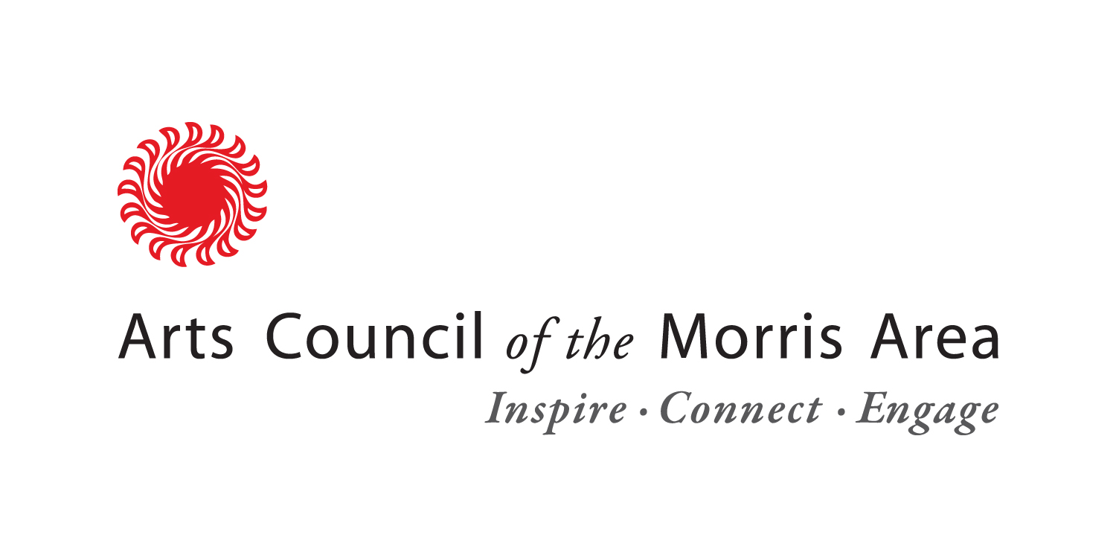
All inquiries about the purchase of art should be directed to Anne Dodd at the
Arts Council of the Morris Area, (973) 285-5115, ex. 15, or adodd@morrisarts.org.

Major Sponsor:


