3rd Saturdays at Morris View - 2014

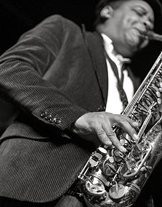

April 19: The Latin Sax Quartet. Their website: <http://www.latinsaxquartet.com> featurings a listing for 3rd Saturdays! The audience is in for a rare treat! These outstanding Cuban classical saxophonists have worked and performed closely with the great Paquito D’Rivera who describes them thus:

*Inspired in Marcel Mule's French school, and followed in Havana by my father Tito and his "Conjunto Sinfonico de Saxofones" in 1943, Oscar Gongora and his Latin-Sax Quartet are an ideal example of what the Cuban classical school of the saxophone has become. The group offers a perfect balance between the academic discipline and the typical charm and complex rhythms inherent to Cuban music. A real Sax pleasure!  -Paquito D'Rivera*



May 17: Hillary Marie Michael, tap dancer

As an acclaimed soloist and ensemble member, Hillary-Marie has been featured at the world renowned Apollo Theater, NJ State Theater, NJPAC, SOPAC, The Copacabana, The Duke Theatre, F.I.T., Peter Norton Symphony Space, Bank Arts Theater and Smithsonian Museum, among many others. She has performed alongside Maurice Chestnut at the Harlem Stage and in The Above Ground Project, as a regular guest artist with the Boston Tap Company in their signature show "Rhythm in the Night", in Derick K. Grant's production "Rhythm is Our Business" and Christopher Scott's production "W-L-U-V". Hillary-Marie performs weekly at Harlem's historical Cotton Club as a part of Dormeshia Sumbry-Edwards' "Sophisticated Ladies".

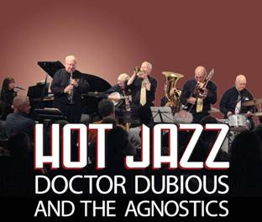

June 21: Dr. Dubious and the Agnostics (1920’s hot jazz, 5 piece ensemble)

From classic traditional hot jazz to swing, this group does it all.  Since 1998, Doctor Dubious has performed in the New Orleans and Chicago styles in the tri-state area.  This five-seven piece Dixieland Jazz Band’s music swings with horns in sync with each other and a driving rhythm section.  This New York City Jazz group includes Doctor Dubious himself, Tom Duncan on clarinet, saxophones and vocals; cornetist, composer and music professor Bart Bartholomew; jazz vocalist, educator, composer and keyboardist Karen Bartholomew; trombonist Dick Dreiwitz; tubaist Barbara Dreiwitz; drummer and cornet doubler Dave Brown; and banjoist/guitarist Monroe Quinn.

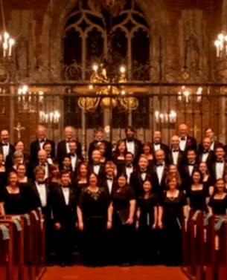  
July 19: Harmonium Choral Society

Winner of the prestigious Chorus America’s 2009 Education Outreach Award, this premier vocal ensemble is renowned for its richly diverse programming and high artistic level. Celebrating its 35th anniversary season, Harmonium presents a highly diverse program ranging from the Renaissance to 21st century as well as international works, from Nigerian to Cuban. Under the inspired direction of Dr. Anne Matlack, members of Harmonium include many music educators and singers from teens to retired folks, performing *a capella* as well as with percussion and handbells.

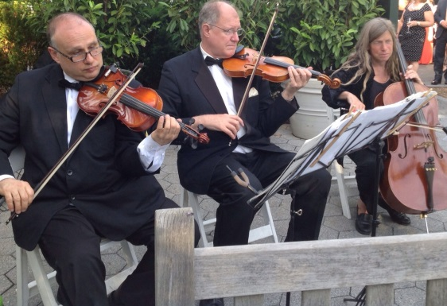  
August 16: Duo from Claremont Strings & Ensembles

On August 16, a duo from Claremont Strings and Ensembles will perform a program of music spanning three centuries from Bach and Vivaldi  to Fauré, Tchaikowsky and Weil. The Ensemble, a NYC based professional collaboration of top rate instrumentalists specializing in concerts and events, includes core members who are graduates of major conservatories and universities : Juilliard , Mannes MSM ,Yale , Columbia , Harvard , Peabody , Curtis Institute. and Moscow Conservatory just to name a few. Collectively they have performed in venues such as Avery Fisher Hall, Alice Tully Hall, Town Hall, Weil Hall, Zankel Hall, the new Rose Center in NYC and others. The ensemble has also collaborated with opera and jazz singers and several members have appeared in movies under SAG auspices. Founder and cellist Vivian Penham attended Juilliard and Columbia and was a Goethe Institute Fellow at the University of Freiburg. She freelances with the New England Symphonic Ensemble and Scandia Symphony, Teatro Lirico Europa. She was solo cellist on tour with *Phantom of The Opera* in Asia and South America.

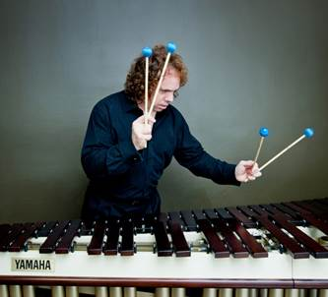

September 20: Greg Giannascoli: Marimba Virtuoso

The blinding speed and precision of this marimba/percussion artist have won him top honors at numerous, prestigious international competitions. Giannascoli performed at Carnegie Hall, internationally and on CBC, NPR radio and PBS TV. On the Juilliard faculty, he leads master classes at top conservatories and has recorded five acclaimed solo CDs. *Splendid Music Magazine* wrote, “Giannascoli’s performance…was nothing less than astonishing, both in terms of artistry and virtuosity… a startling display of clarity and precision,” while *Classical New Jersey* stated, “Here is music played so well it would capture and hold anybody’s attention indefinitely.” Giannascoli is truly the mallet master. [www.greggiannascoli.com](http://www.greggiannascoli.com);

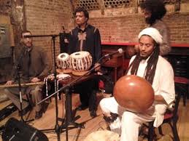 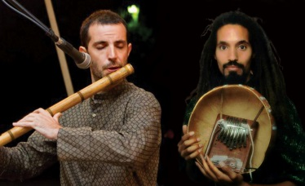

October 18: Afrika meets India: Kevin Hylton Duo

[Afrika meets India](https://www.facebook.com/AfrikameetsIndia) is an innovative and exciting new project, led by Kevin Hylton,  that brings together New York's finest practitioners of Indian and Afrikan traditional music for a powerful blend of groove, melody and rhythm! Kevin Nathaniel Hylton graduated Yale University in 1982 as Scholar of the House for Fine Arts and has since devoted himself to African music, performing on (and building) traditional African instruments, composing African-inspired music and working with multiple ensembles, performing in NYC and internationally. His workshops and lecture/demos have been presented at Juilliard, Lincoln Center and other top institutions. He was commissioned by Carnegie Hall to write and direct their fall 2005 Family Concert and, with Symphony Space, he has created a program for African music that visits NYC schools and produces a concert every December. An accomplished percussionist and well-known specialist on the *mbira* and *shekere*. He worked extensively with Zimbabwe’s *mbira* legend Epha Mujuru and with master drummer Chief Bey. Along with 9 recordings and his most recent releases (*African Dreams,* the Narada Collection *African Voices*  and *Mbira Magic),* he has taught tens of thousands of people all over the world the art of *mbira* making and playing. Visit his online interactive mbira which he created for PBS and National Geographic.

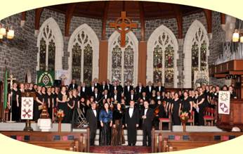

November 15: Morris Choral Society

Since its founding, the Choral Society, under Artistic Director Wayne Walters, has contributed to the local choral scene throughout Northern NJ area as well as appearing on NBC TV’s “First Estate” program. Its concert year, in general, includes two major concerts in and about Morris County. It has also appeared at many Morristown annual celebrations of Independence Day, the historical Holly Walk, its popular Fall Festival on the Green and First Night Morris.  The Society has received international recognition performing successful concerts in England, Ireland, Scotland, Wales, France, Italy, Poland and the Czech Republic.  Additionally, MCS has been represented by “ambassadorial” choral contingents in multi-choral units in eastern Europe, assembling a vast and varied musical repertoire, including music form the Renaissance to the present. Especially moving were the appreciations expressed to all americans by municipal officials at the two MCS concerts in Caen France, on the 50th Anniversary of D-Day liberations.

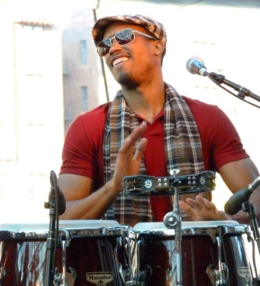Anthony Almonte  
December 20: Almonte  
Coming from New York City, ALMONTE combines together the best of traditional salsa with some hot new sounding trends. A breakdown of the big band GRUPO ARCANO, ALMONTE is led by singer and conguero Anthony Almonte. This eclectic mix of musicians provides a feel-good energy for each and every audience.